**Deployment Of Website Through CI/CD Pipeline Using Ansible, Jenkins, Docker and K8’s**

INTRO

In this project, we are going to create a complete pipeline to build and deploy a web application. During this project, we are going to use as a local version control system, GitHub as a distributor version control system. Jenkins as a continuous integration tool, Ansible for configuration management under deployment tool, Docker for containerisation and Kubernetes as a container management tool. We are going to set up all this environment on AWS. Now, let's see how these tools are going to fit in our DevOps workflow.

Usually, we have the source code with the developers and they commit that code onto the distributed version control system during the development phase. Then we need to build this code, right? For that, we are going to use the continuous integration tool called Jenkins. Once Jenkins built the code, it to generate artifacts. Those artifacts, we need to deploy it onto the target environment. So we needed some tool which can able to deploy the artifacts on the target environment. In our case, we are going to use Ansible as a deployment tool and it can able to deploy our applications on a VM or docker container or Kubernetes, in our case we deploy it on k8s

What is CI/CD::

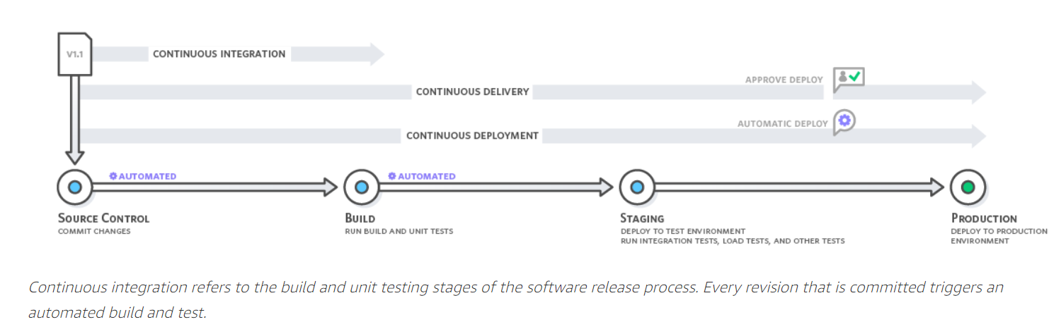

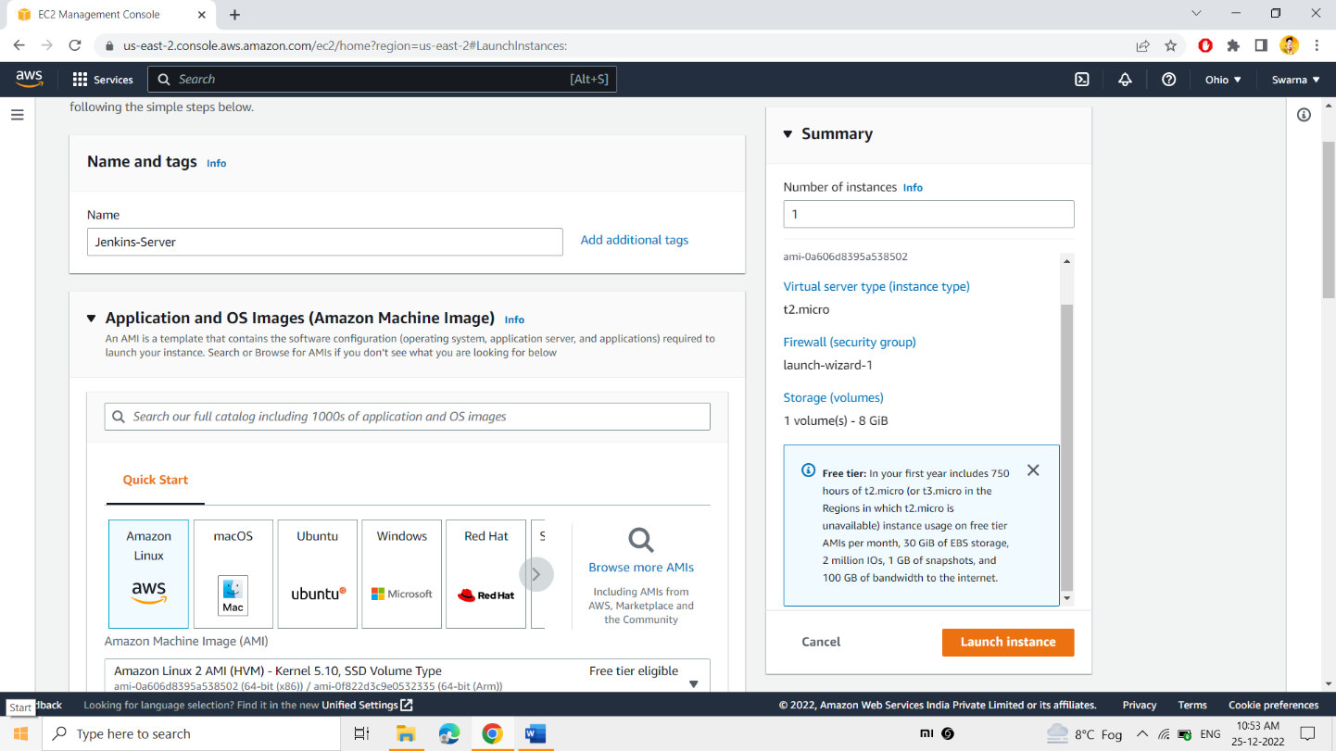

**Initially the server had been launched and named as the “Jenkins-Server” .**

**Amazon-Linux AMI had been selected as the OS.**

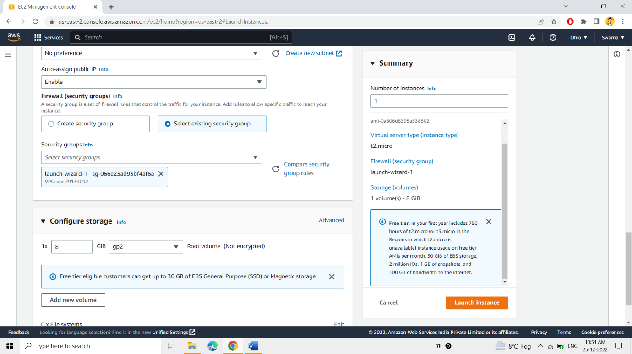

**The existing Security Group includes: -**

* **SSH – 22**
* **HTTP -80**
* **HTTPS – 443**
* **ALL TRAFFIC**
* **CUSTOM TCP = 8001-9000**

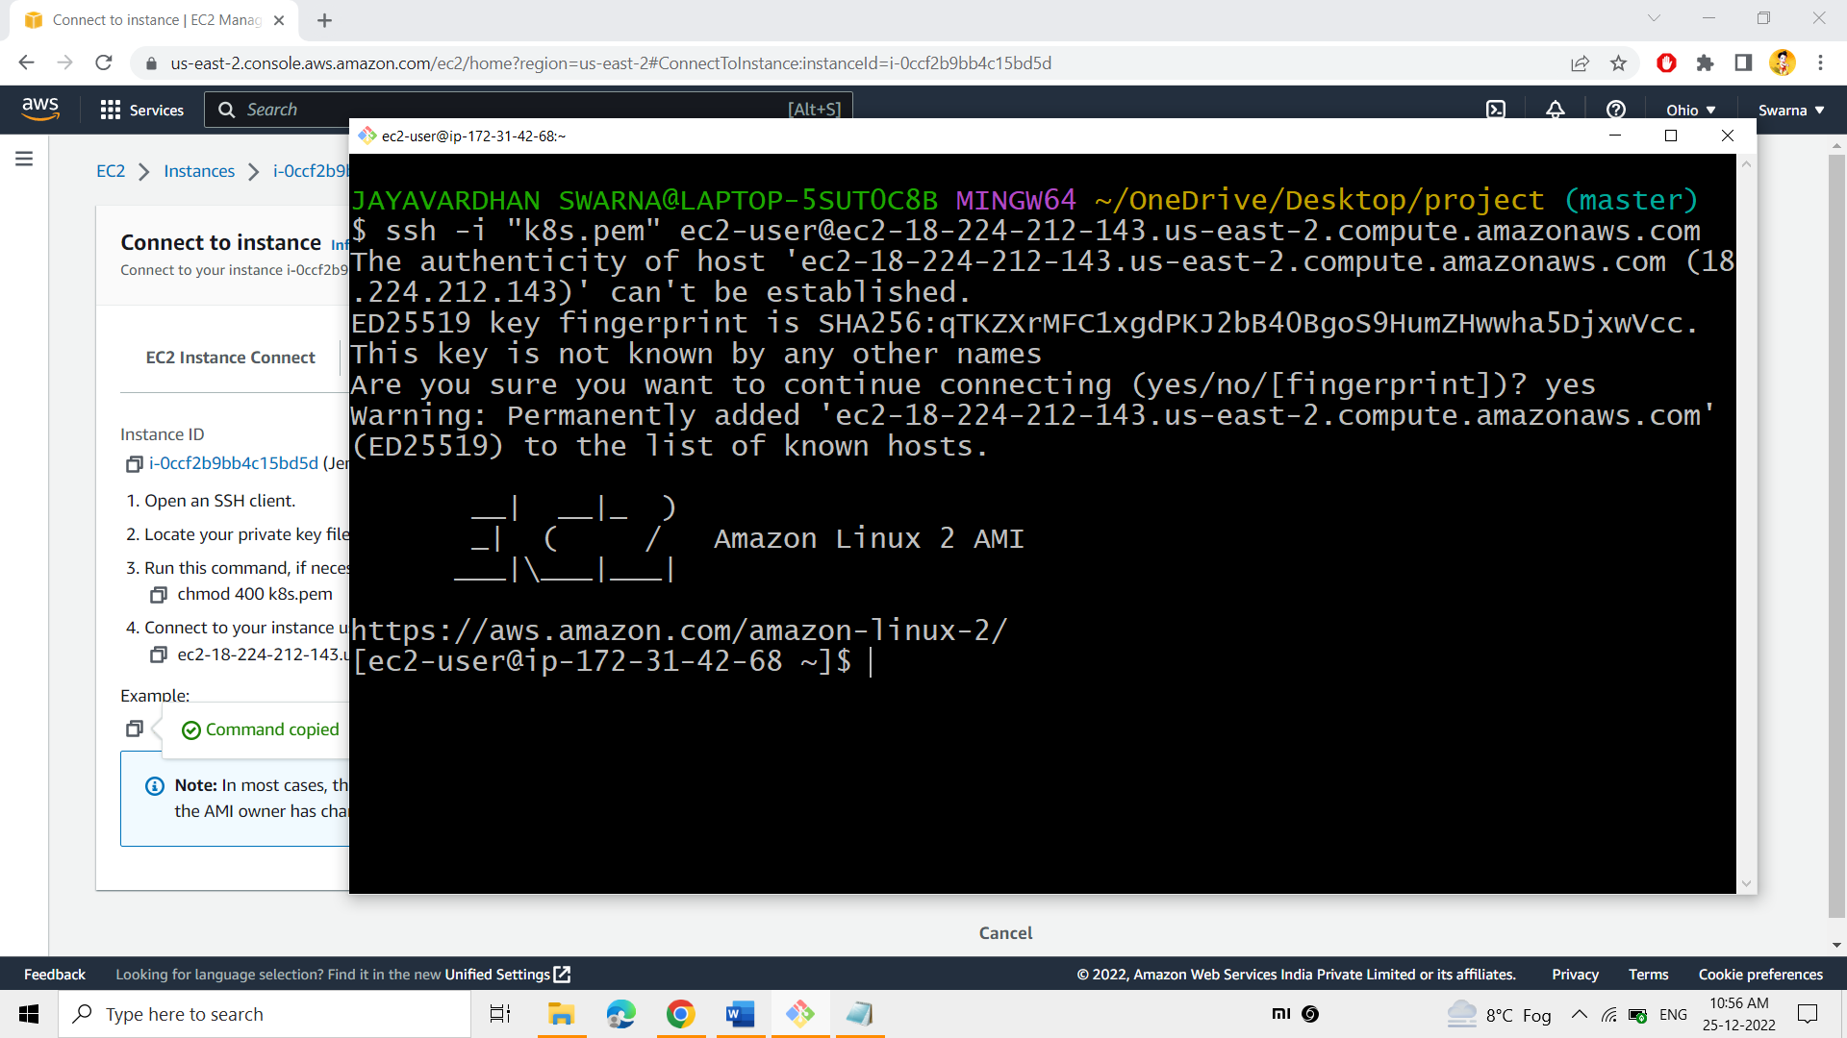

**Securely connected into the “Jenkins-Server”**

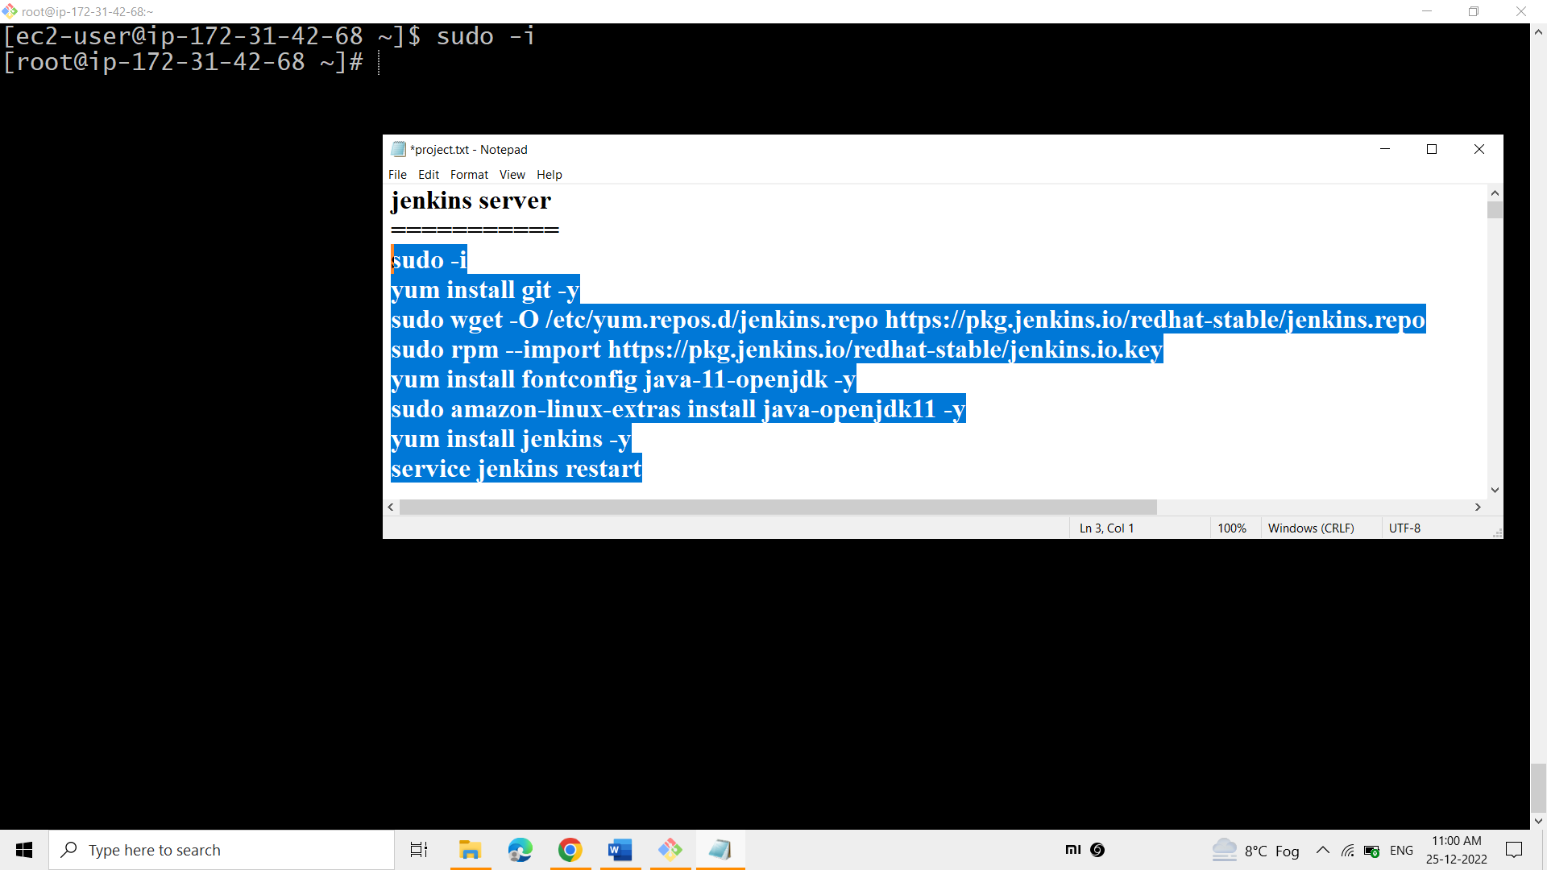

Git has been installed in the Jenkins Server.

Java & Jenkins have been installed in the Jenkins Server.

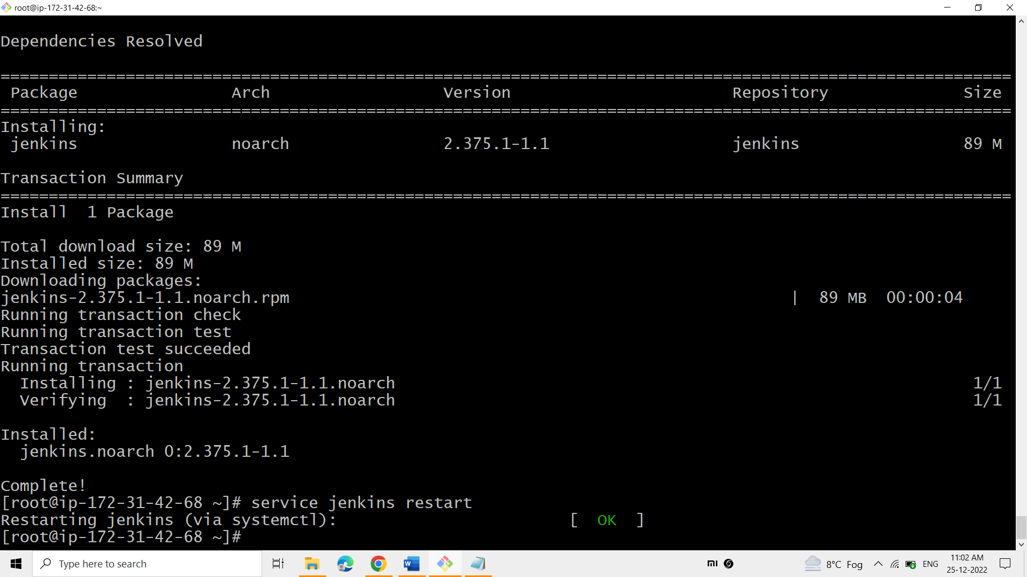

**The above packages have been installed as mentoined earlier and finally started the Jenkins service.**

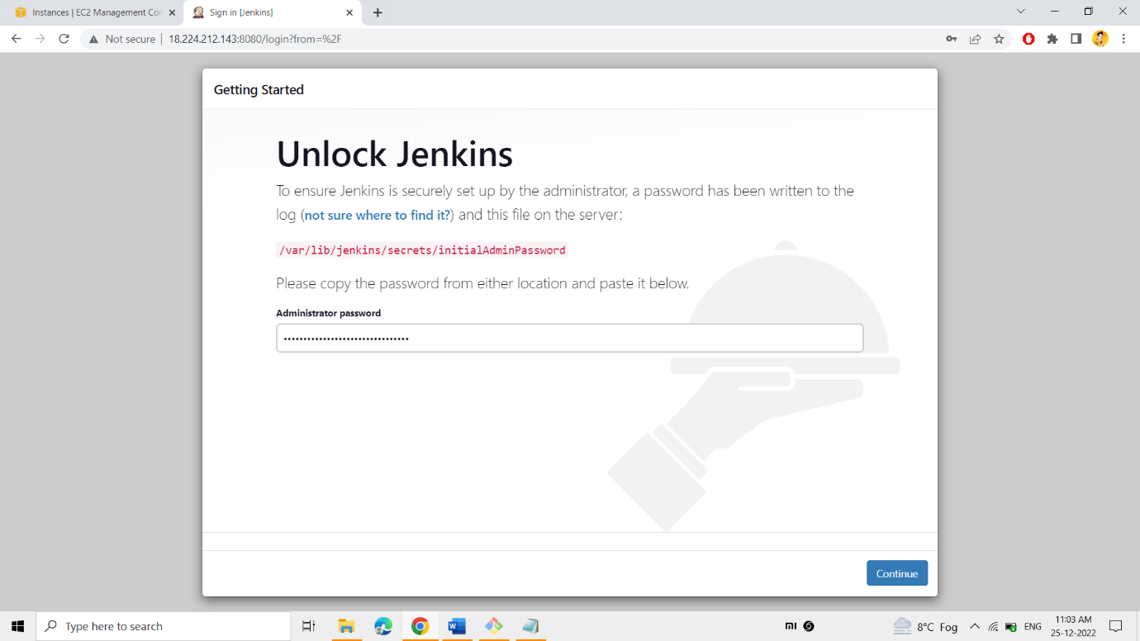

**Login into the Jenkins UI using jenkins public ip address on port 8080.**

**Enter the administrator password using the above specified path.**

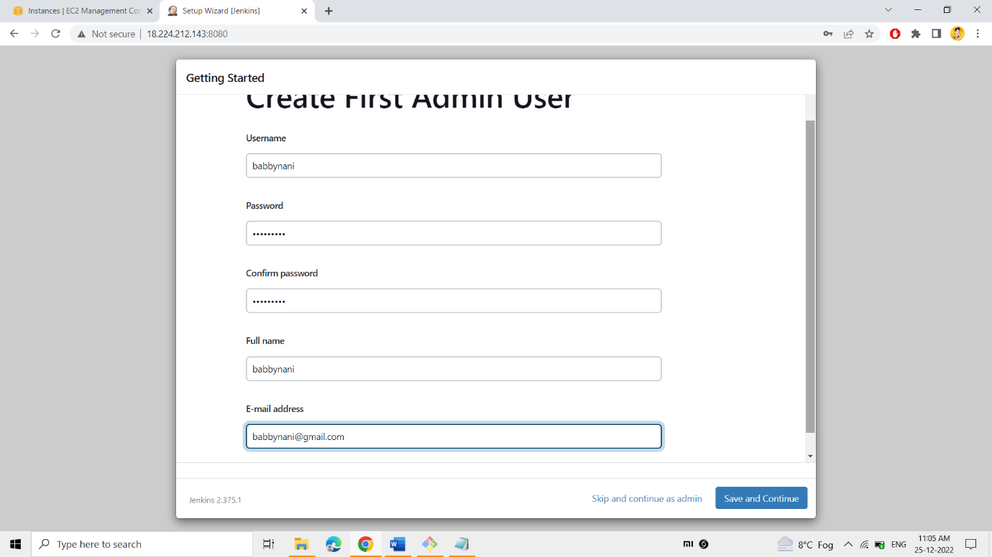

**An admin user has been created for jenkins tool with the above specified details.**

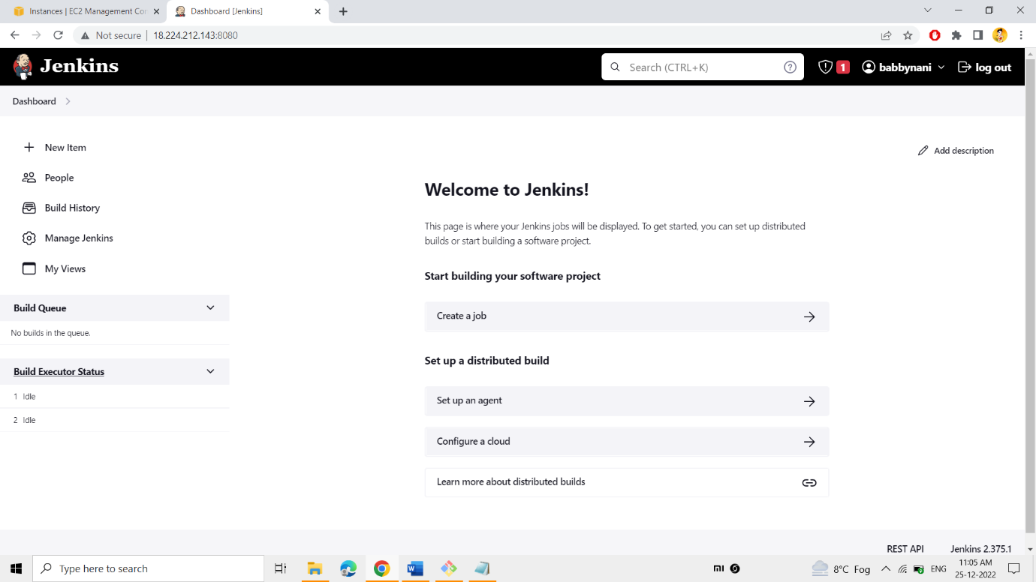

**Finally we logged into the jenkins dashboard.**

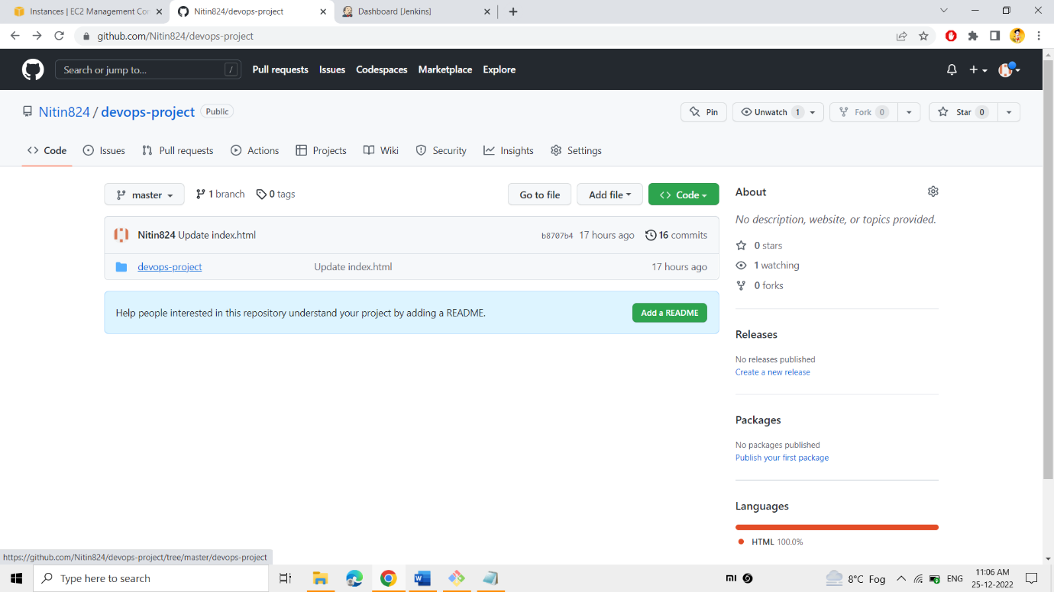

**Already the artifacts have been pushed into the GitHub using the tool Git.**

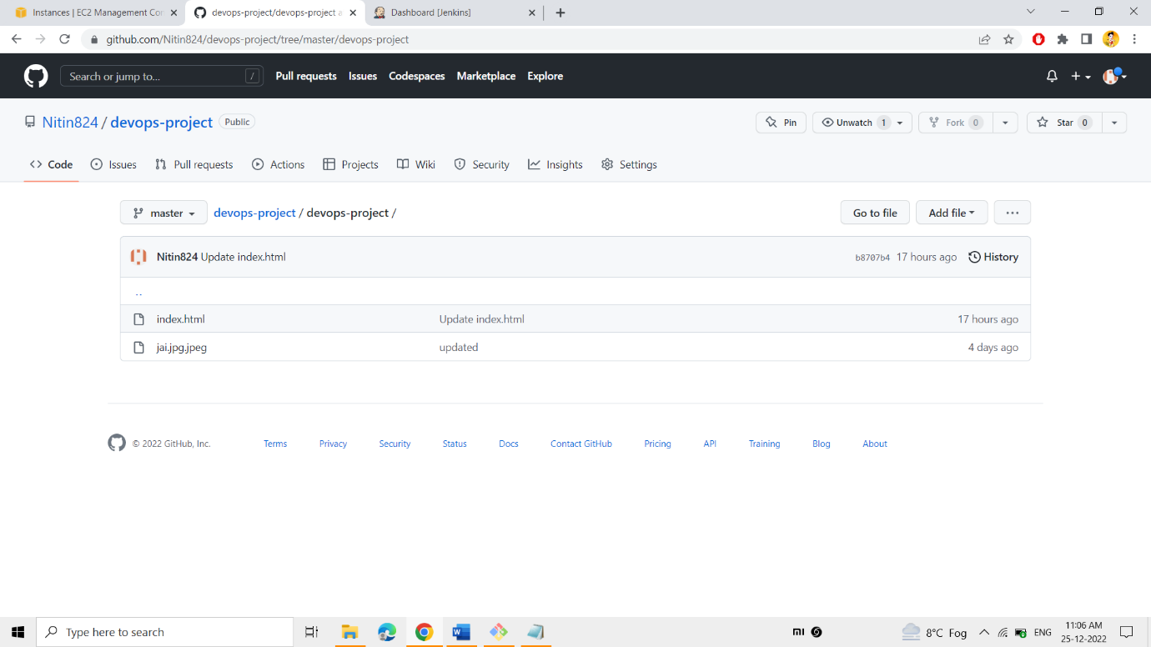

**The GitHub repository consists of these required files for this project**

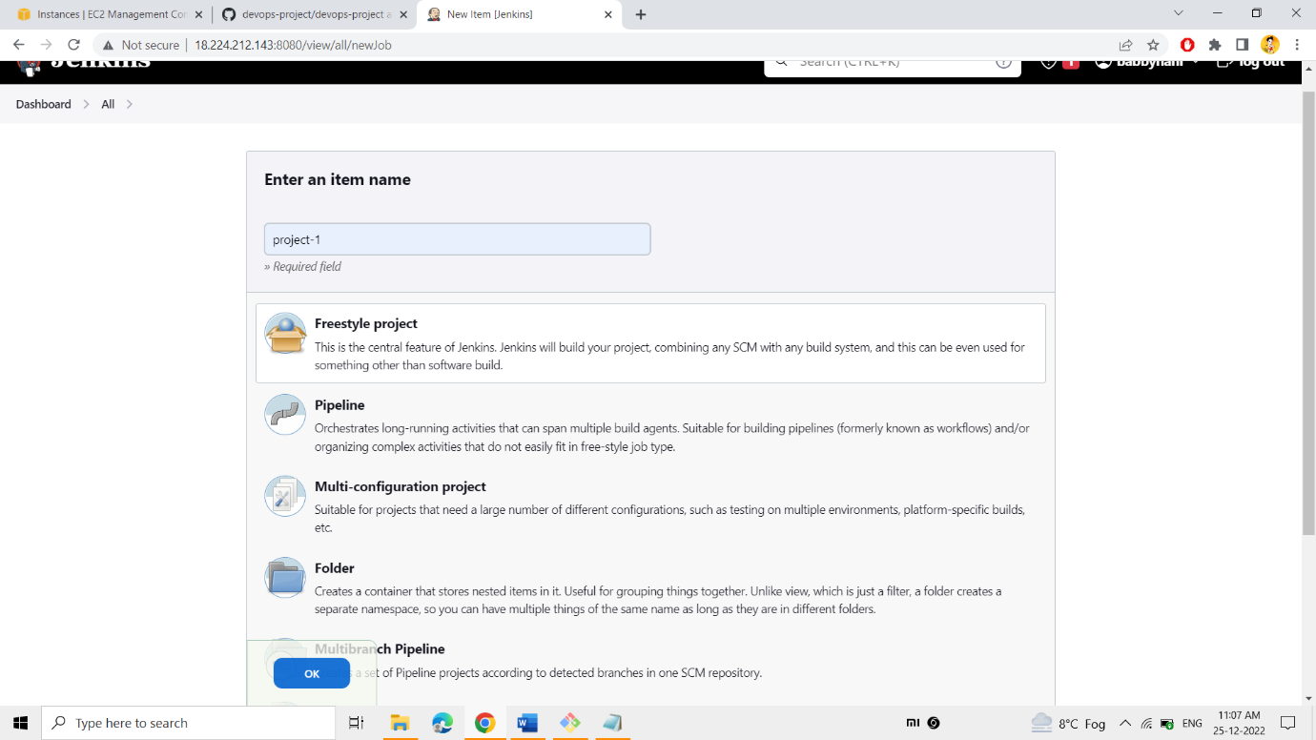

**Create the “Freestyle Project” in the Jenkins dashboard as “project-1”.**

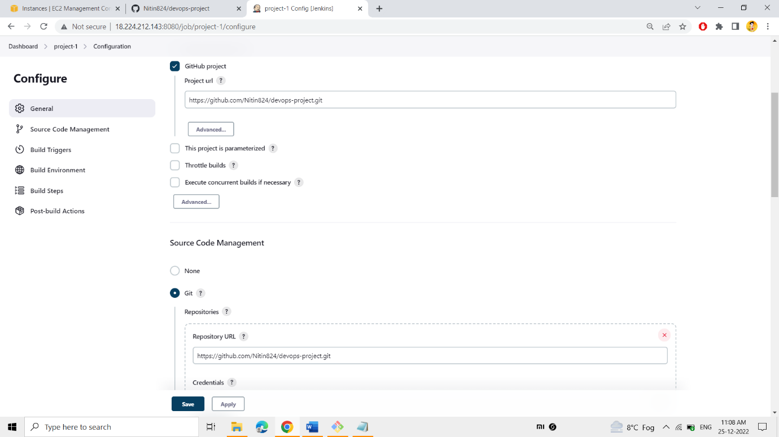

**The GitHub link was mentioned in the project, to pull the artifacts from the given GitHub repo into the Jenkins workspace.**

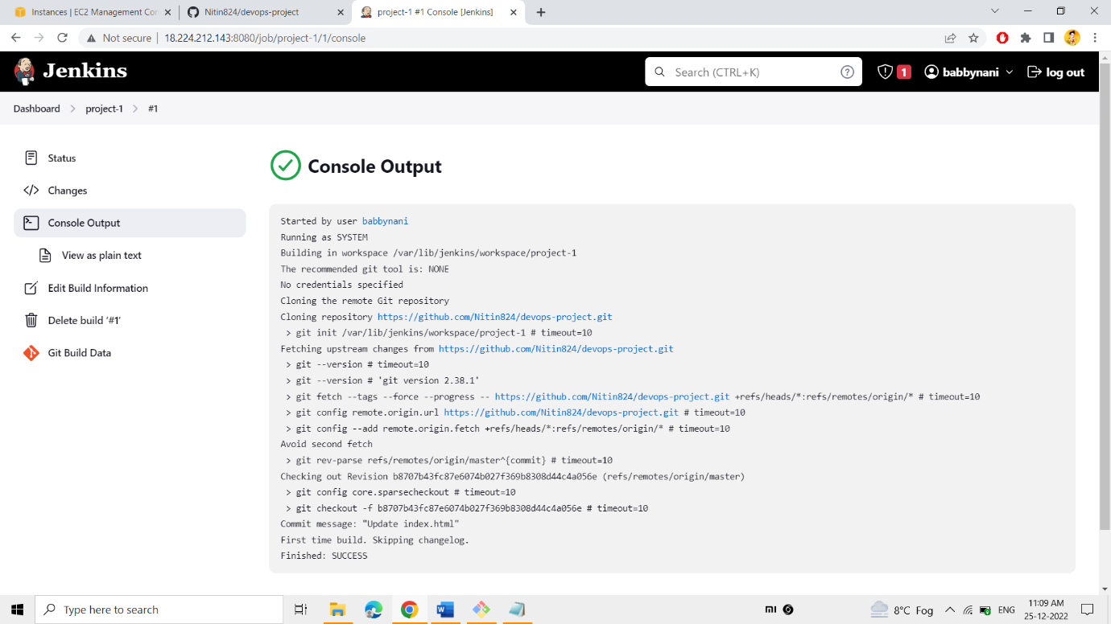

**Finally built the “project-1” to get the artifacts from the GitHub repo into the Jenkins workspace.**

**The build was successful.**

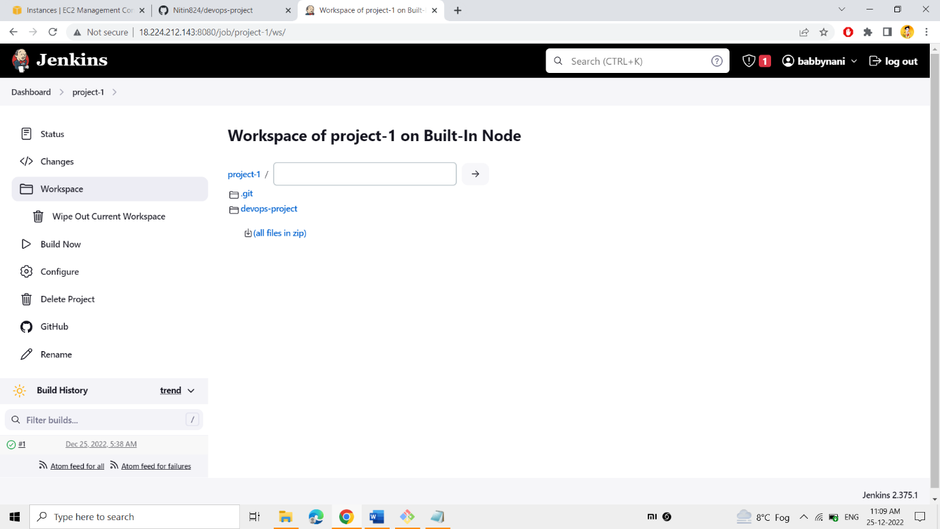

**The artifacts have reached into the workspace of Jenkins.**

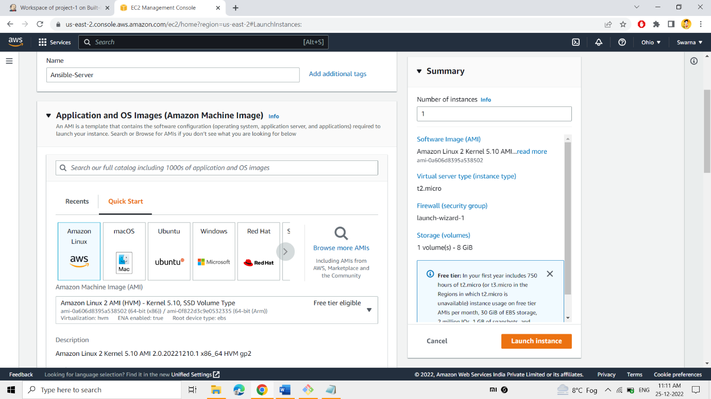

**Initially the server had been launched and named as the “Ansible-Server” .**

**Amazon-Linux AMI had been selected as the OS.**

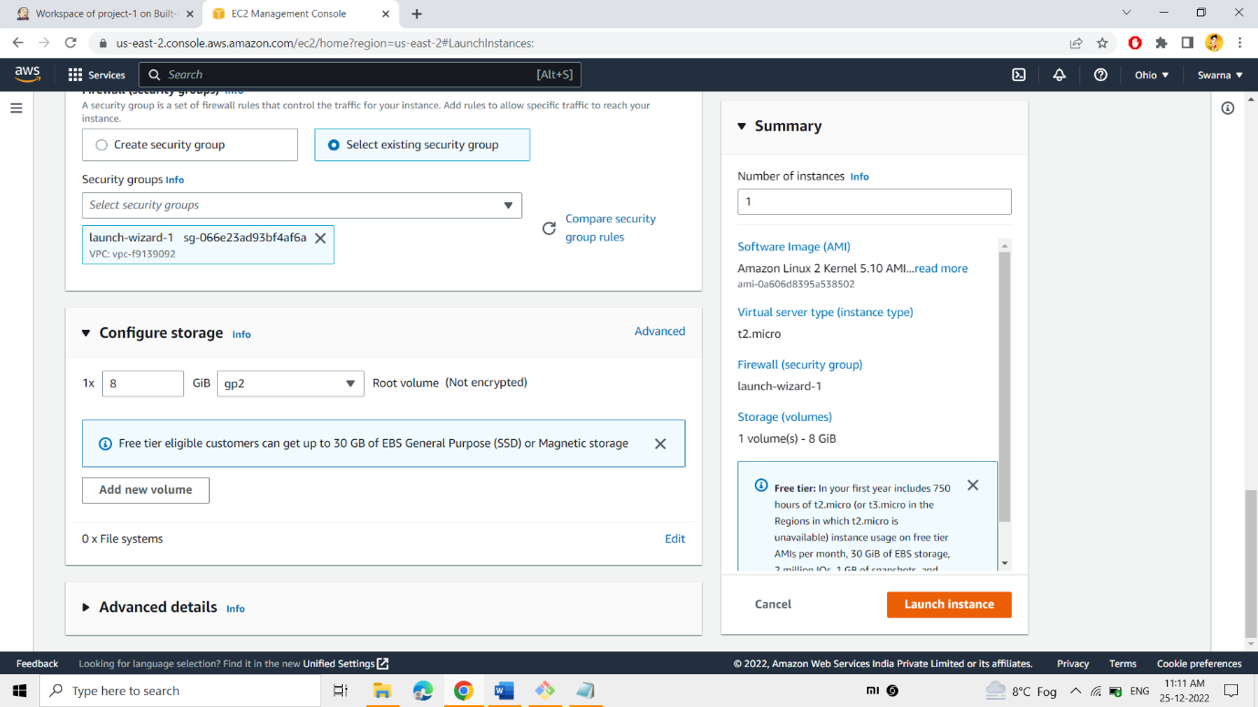

**The existing Security Group includes: -**

* **SSH – 22**
* **HTTP -80**
* **HTTPS – 443**
* **ALL TRAFFIC**
* **CUSTOM TCP = 8001-9000**

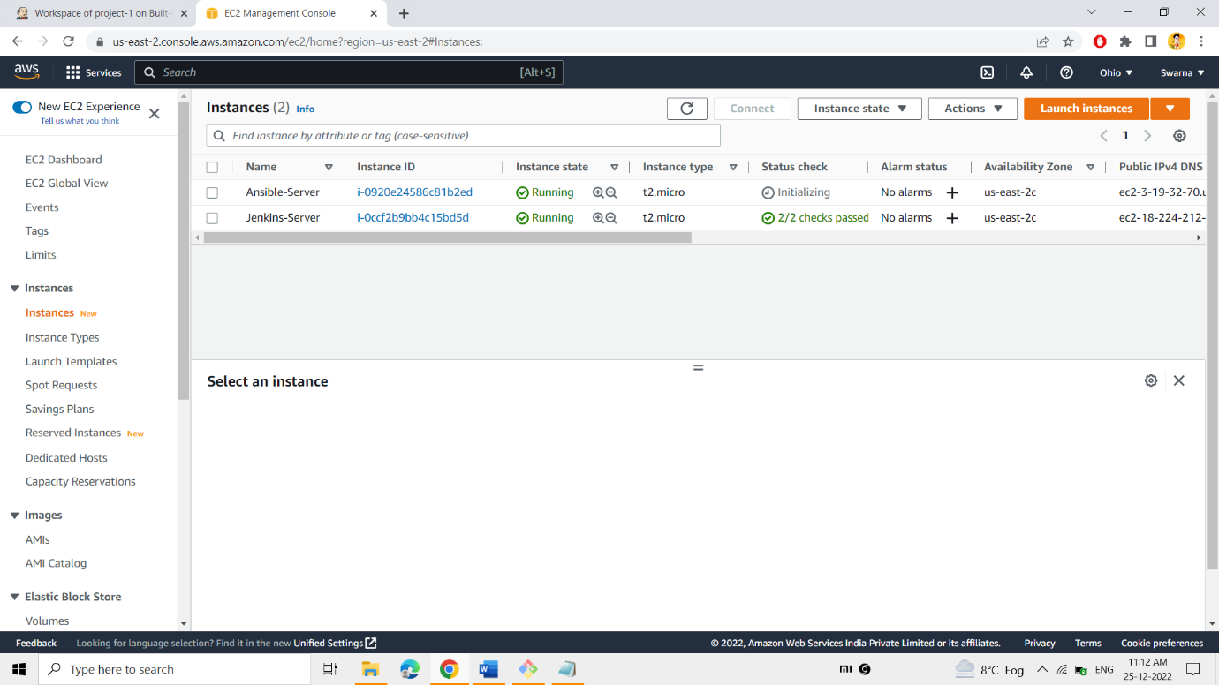

**Ansible Server was running successfully**

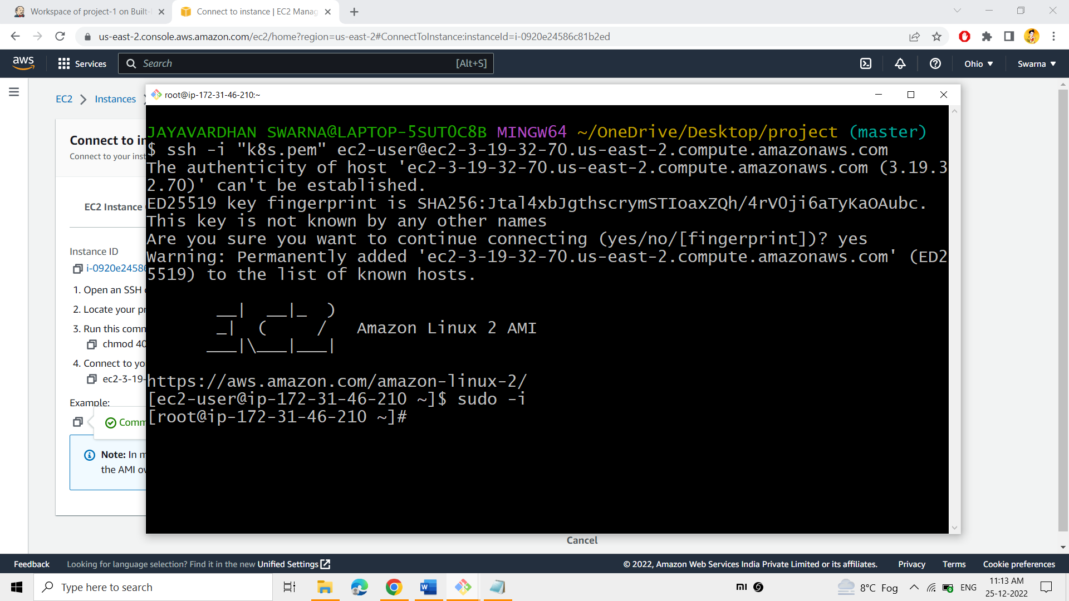

**Securely connected into the “Jenkins-Server”**

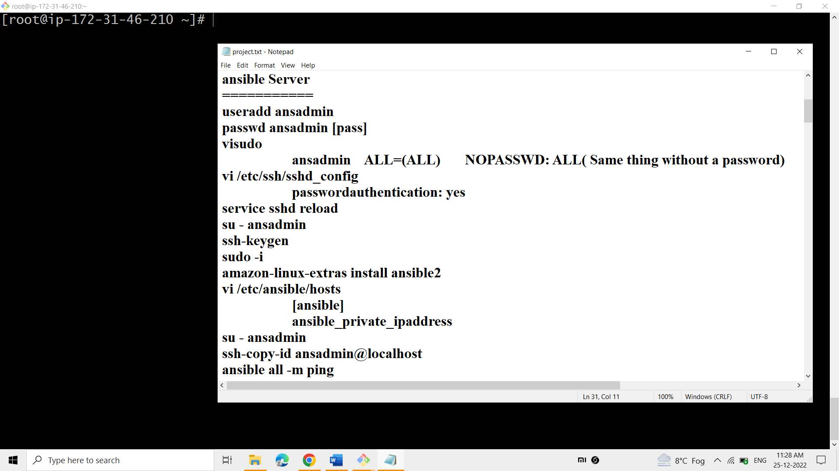

**Following commands are going to be performed in the Ansible -Server to configure Ansible.**

**Initially install the ansible in the ansible server.**

**Add the user named ansadmin in the ansible-server, to connect the user to other server for integration.**

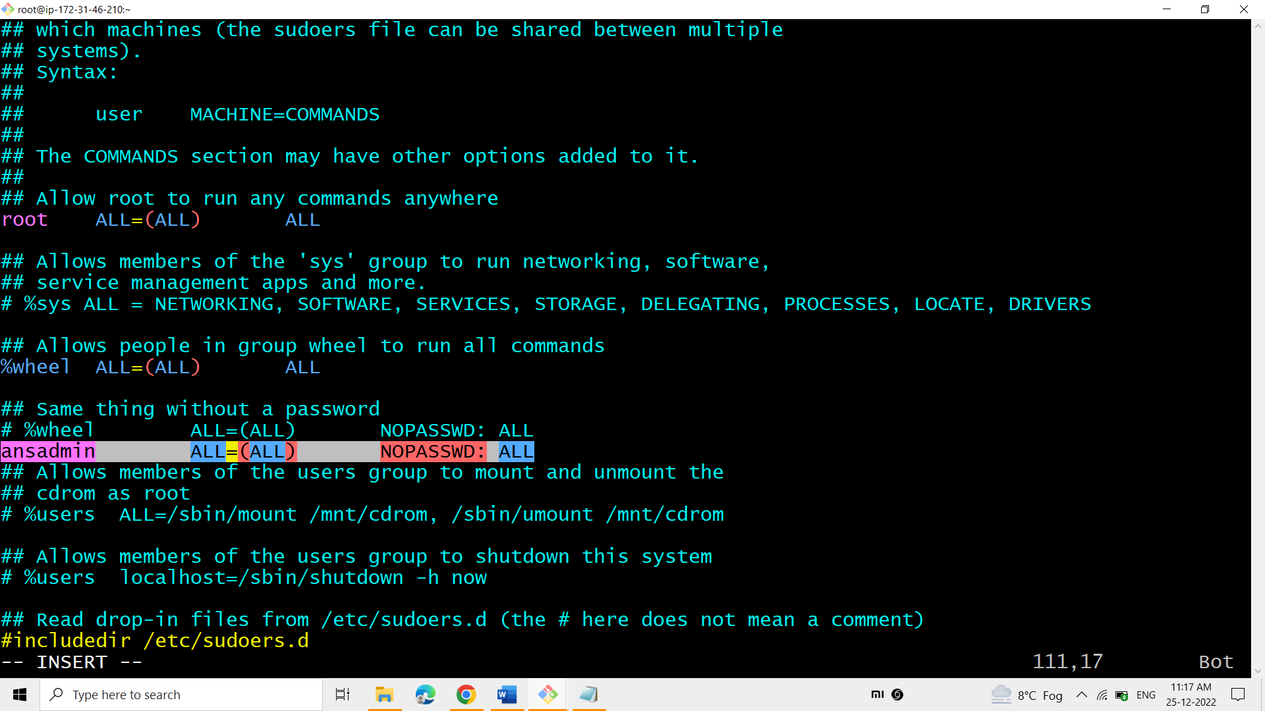

**VISUDO helps in allowing people in the group to run all commands without a password so add ansadmin user.**

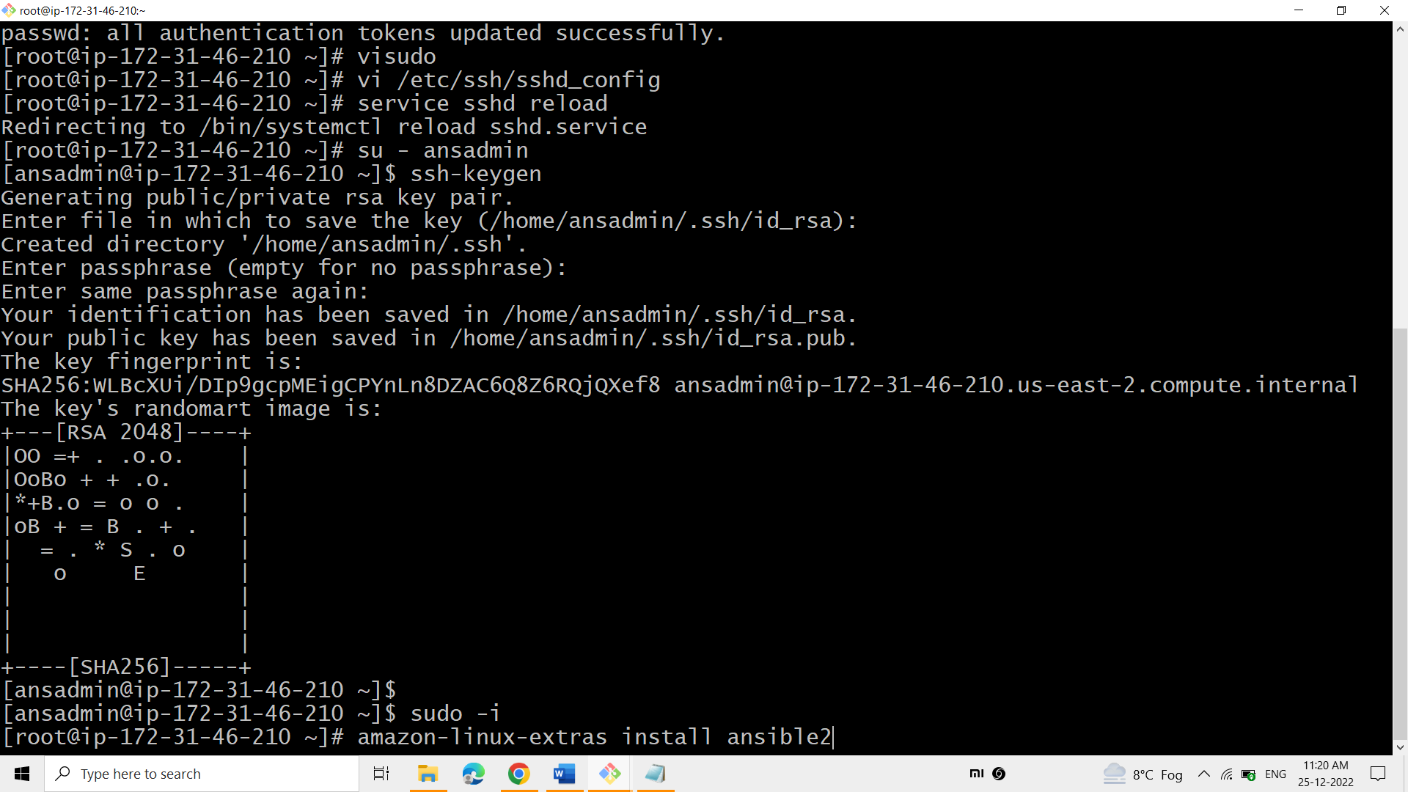

**Next set password authentication to YES.**

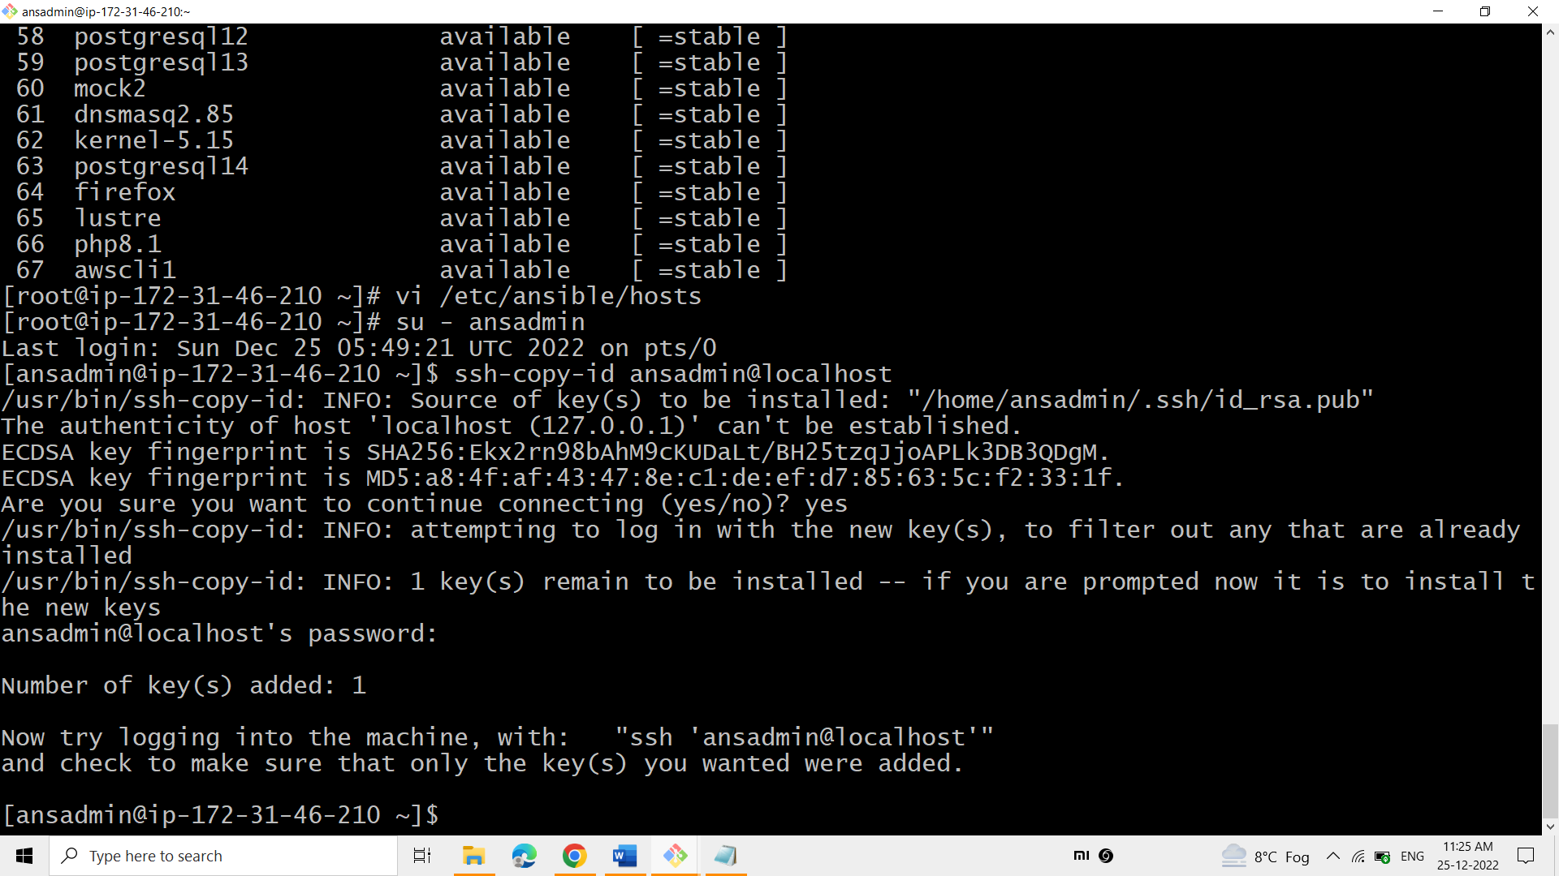

**Add the ansible private ip address to the host file of the ansible server.**

**Now, copy the ssh keys to the ansadmin user.**

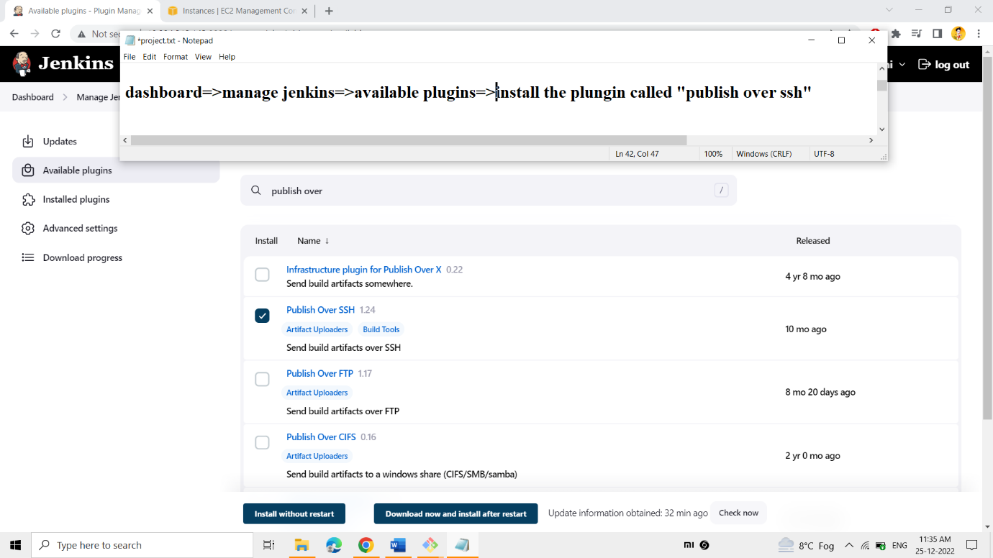

**Add the plugin called “publish over ssh” to connect the Jenkins server with ansible server.**

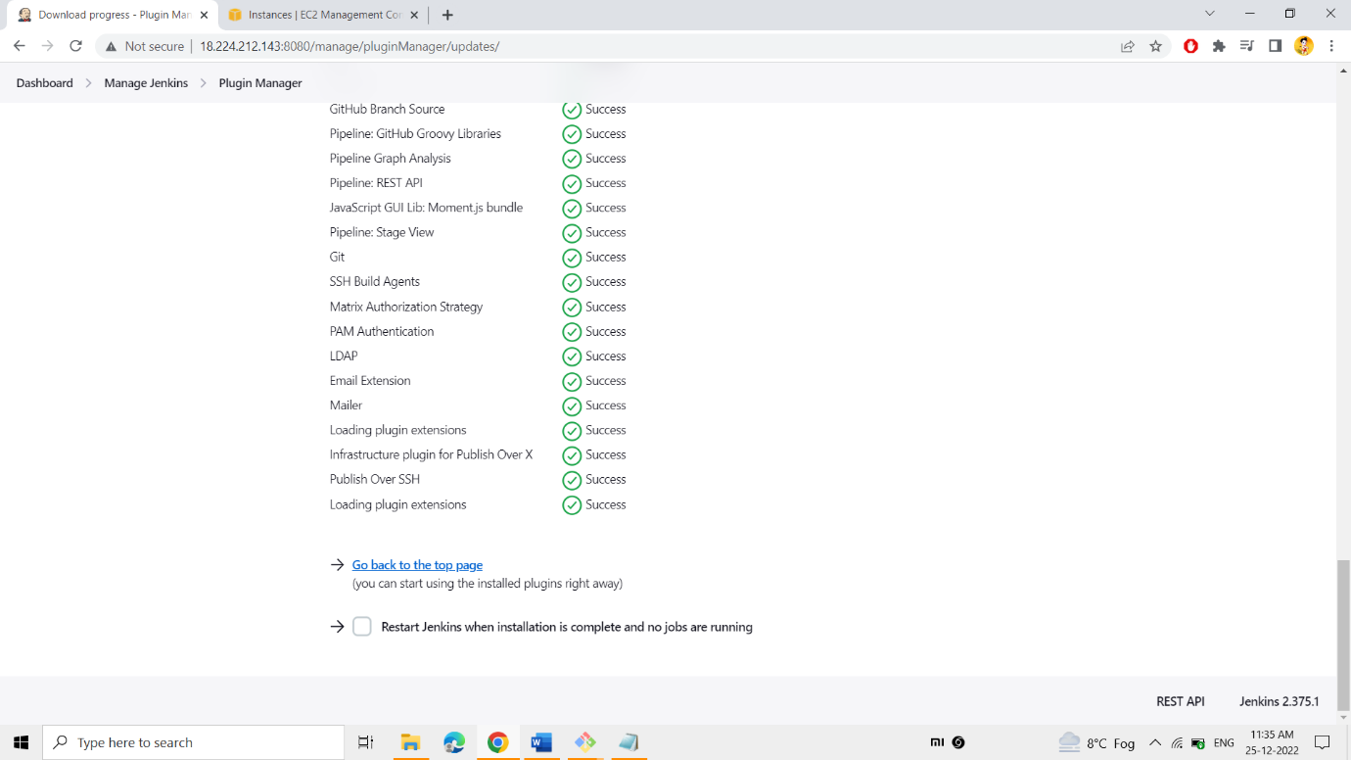

**Picture represents that the plugin was installed successfully.**

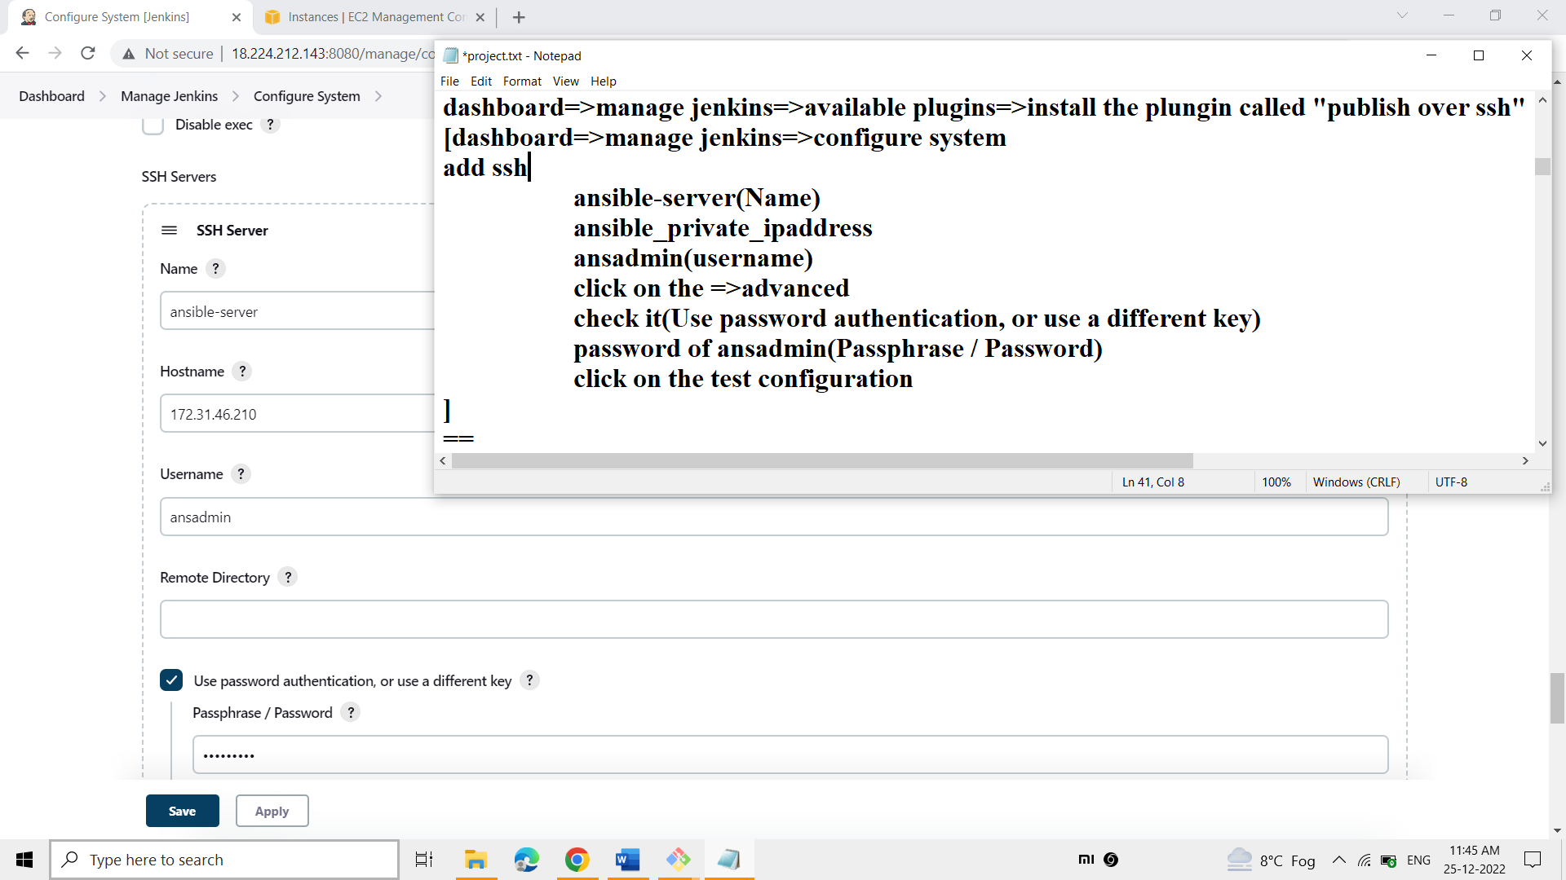

**To transfer the artifacts from Jenkins server to the ansible server we need certain user. So ansadmin user was created and specified user details at here, such as**

* **ansible-server_private_ip**
* **user_name**
* **user_password**

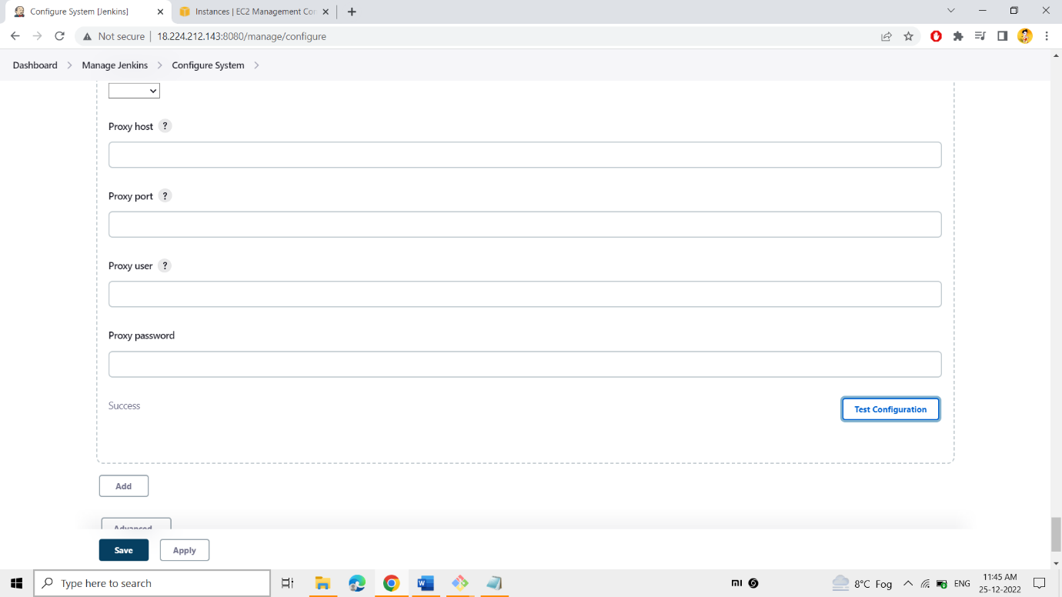

**The picture represents the connection b/w the user of ansible-server and Jenkins was successful.**

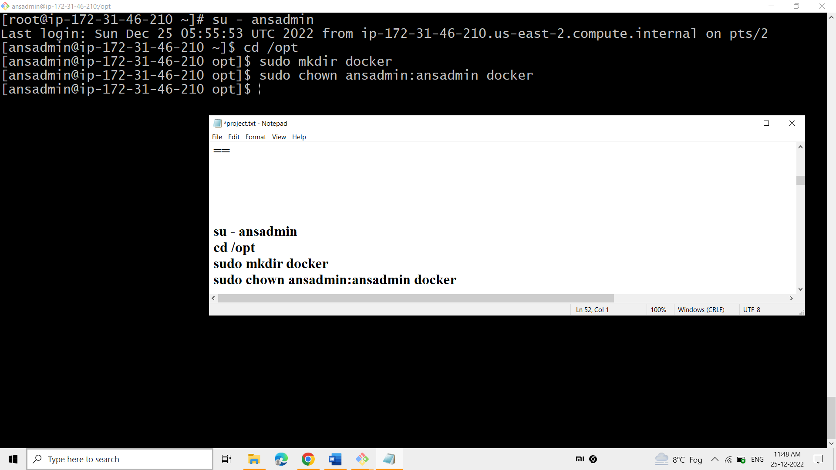

**At the ansible-server create the folder at the /opt/ as docker, to get the files from Jenkins workspace to here.**

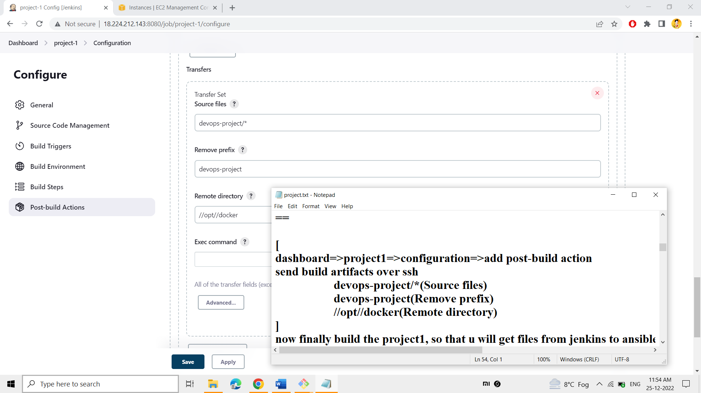

**Add the option of “send build artifacts over ssh” under the post-build action.**

**At here, add the -**

* **Source files = (Transfer all the files present in the workspace of Jenkins, devops-project dir)**
* **Remove prefix = (It removes devops-project dir and transers all files inside the devops-project dir into the remote server)**
* **Remote directory = (Transfer all the files into the /opt/docker/ path in the ansible-server)**

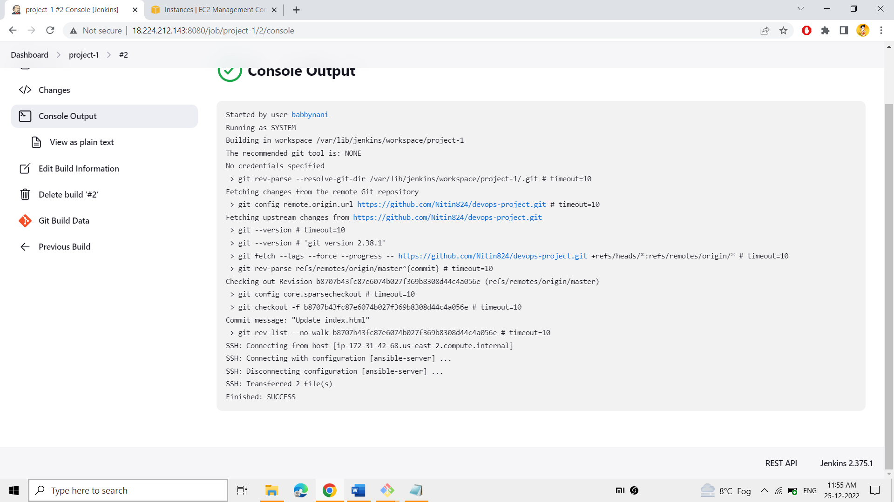

**Finally build the project-1 such that the files present in the devops-project dir will be transfered into the ansible-server of the path /opt/docker/**

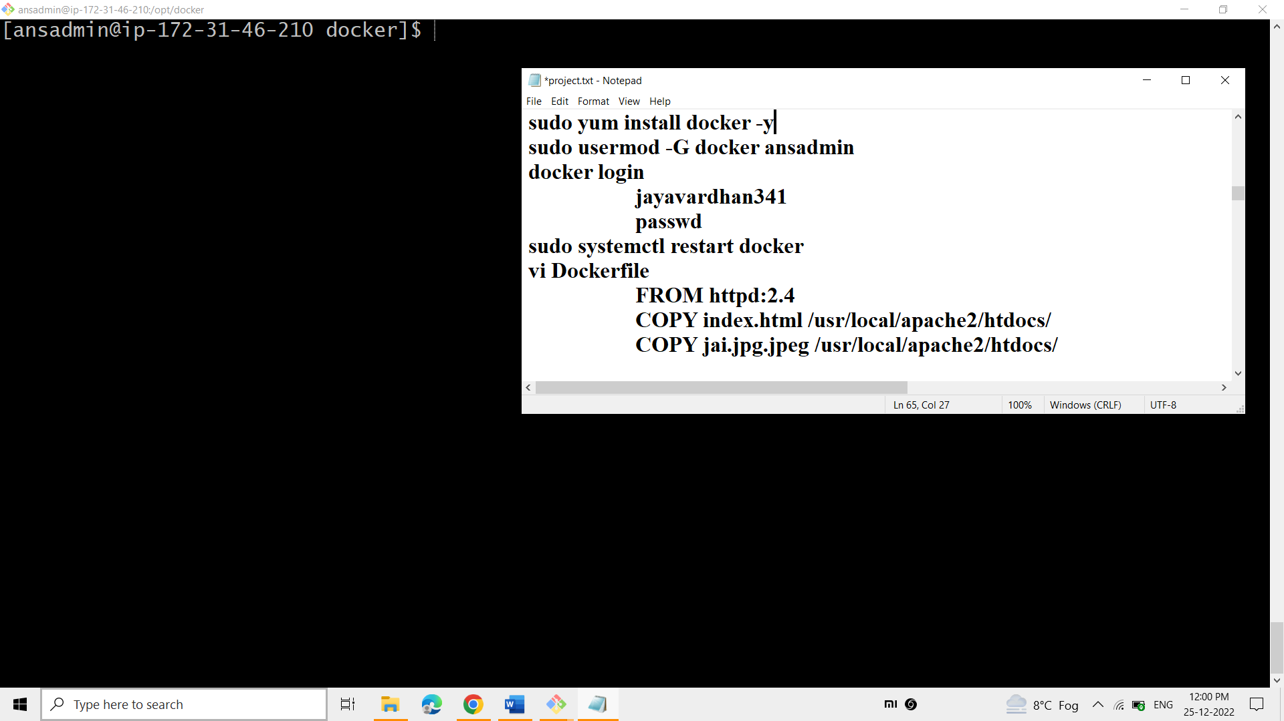

**Now the files were transferred at here.**

**Now add the ansadmin user under the docker group (defaultly creates when docker installed).**

**Login into the docker hub using “docker login” such that the docker comes to know the account of the docker hub.**

**Now write the Docker file to create your own image using the httpd image by**

1. **Copy the transferred file from docker folder to the httpd path folder**

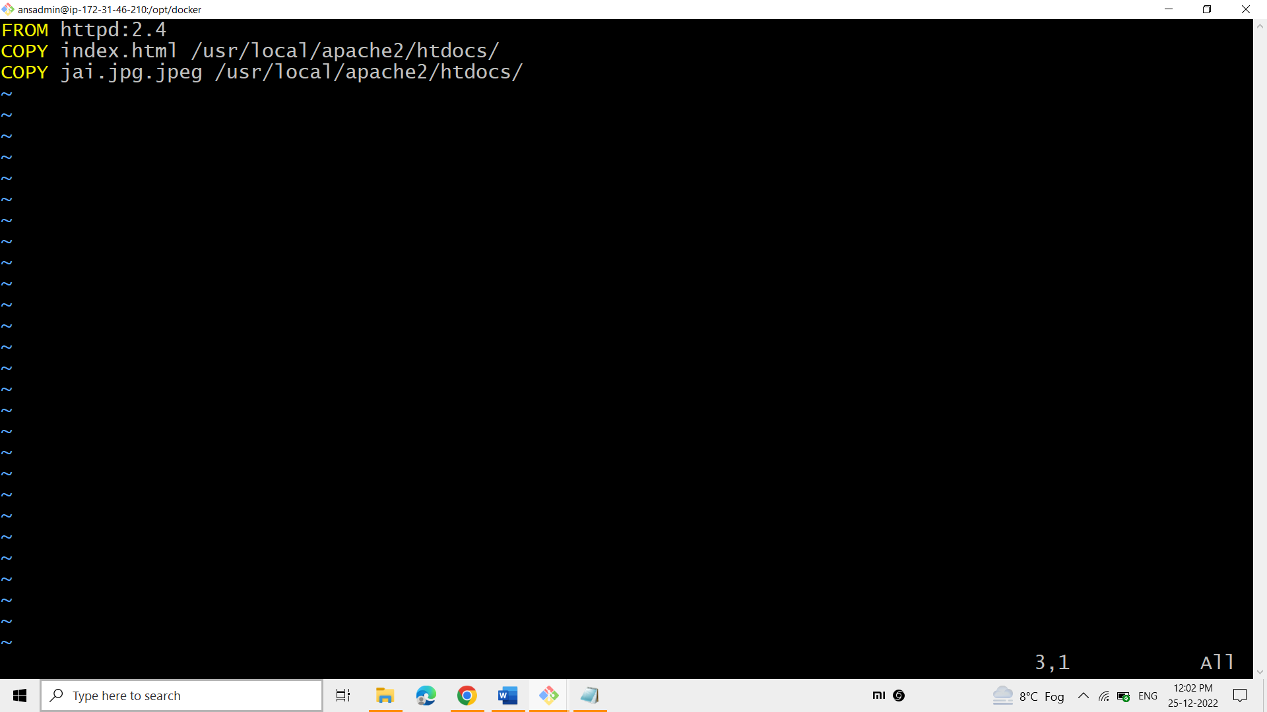

Copy the website files into the above specified website i.e., the websites files copies into the httpd image of the docker. (This is just the path of the httpd image of the docker)

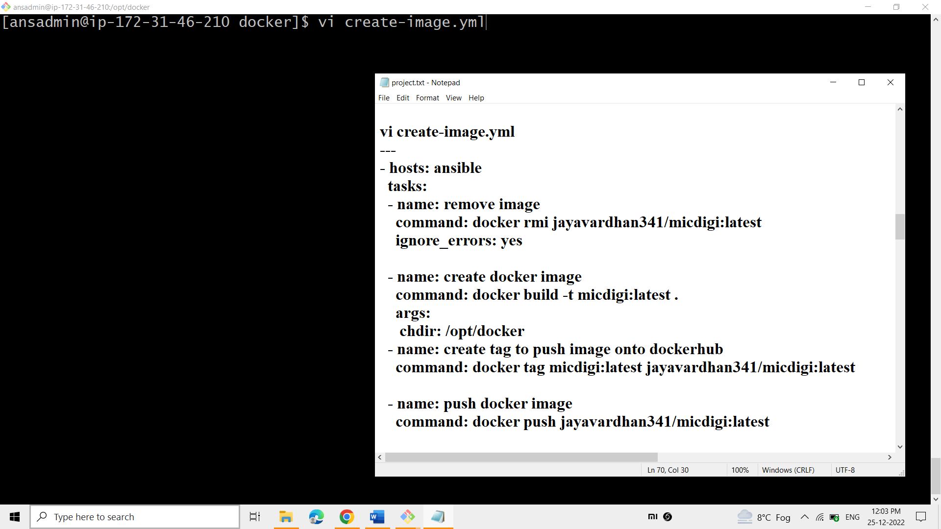

This crete-image.yml playbook is useful in automating the

1)If already presents the same image, deletes the old image and builds the updated image.

2)creation of the docker image using the docker-file.

3)Before pushing into the Docker hub, tagging is necessary

4)pushing the image into the dockerhub.

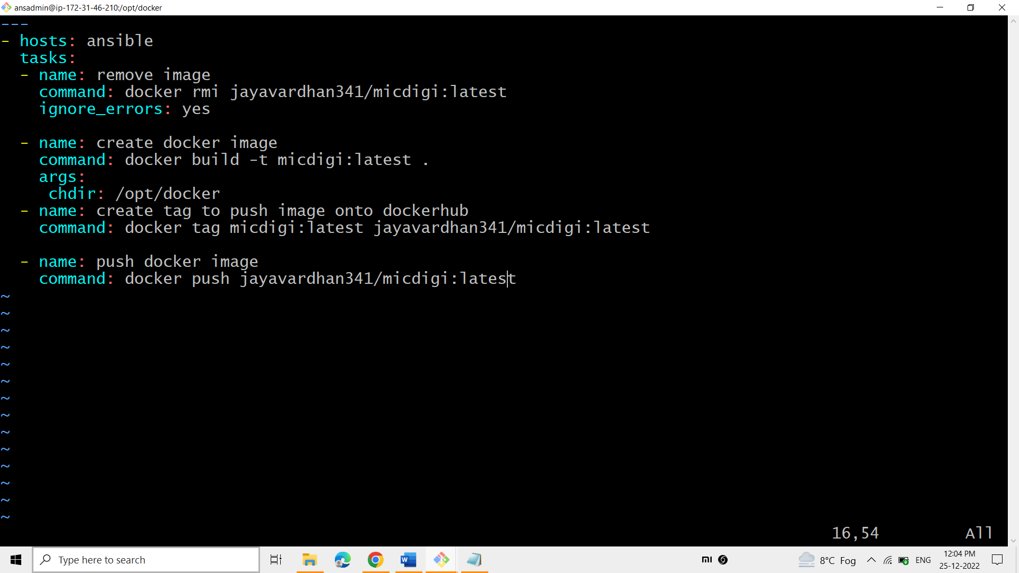

**This is how the playbook looks like.**

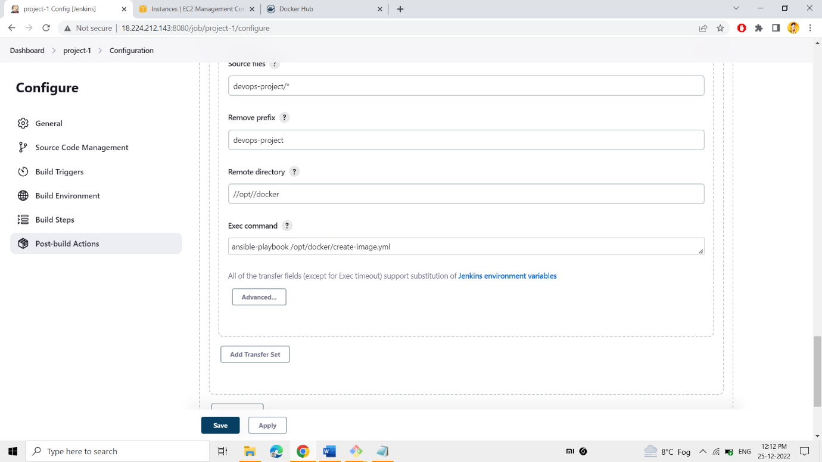

**Now in the filed of Exec command, give the command to automate your playbook.**

**When you build project-1, the playbook creates image and pushes into your docker hub.**

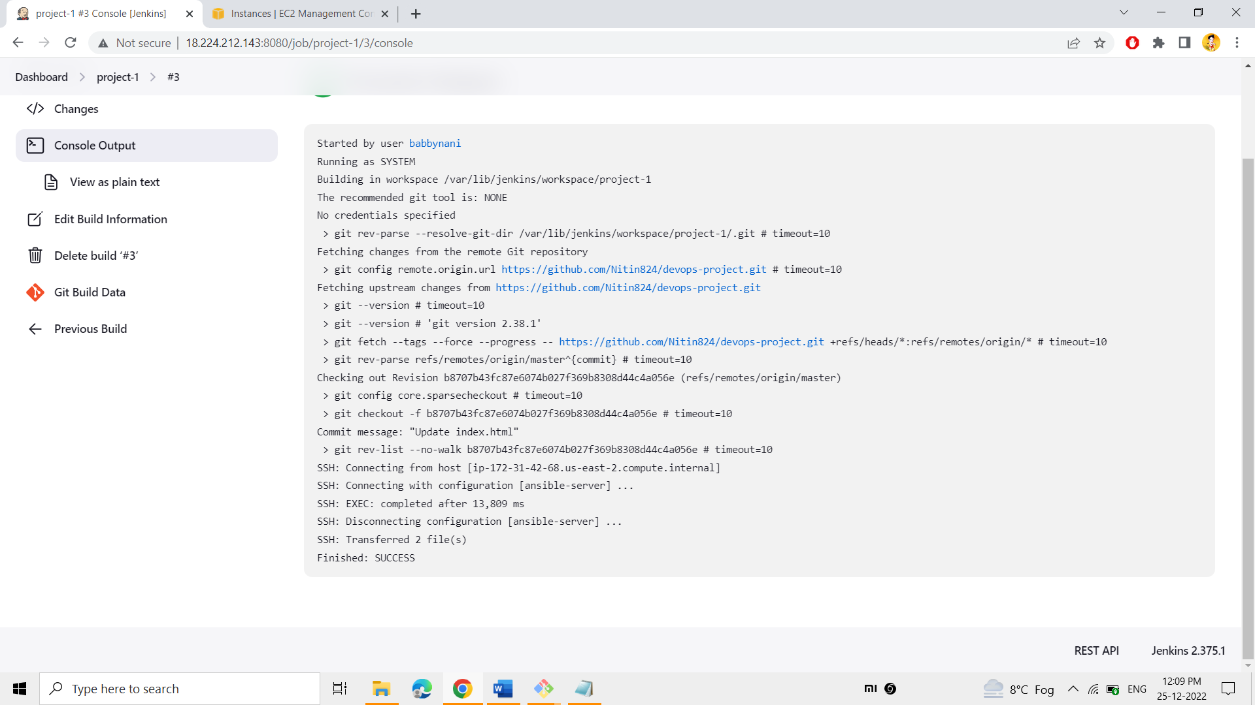

**It represents the build was successful.**

**The image has been created and pushed into the docker hub.**

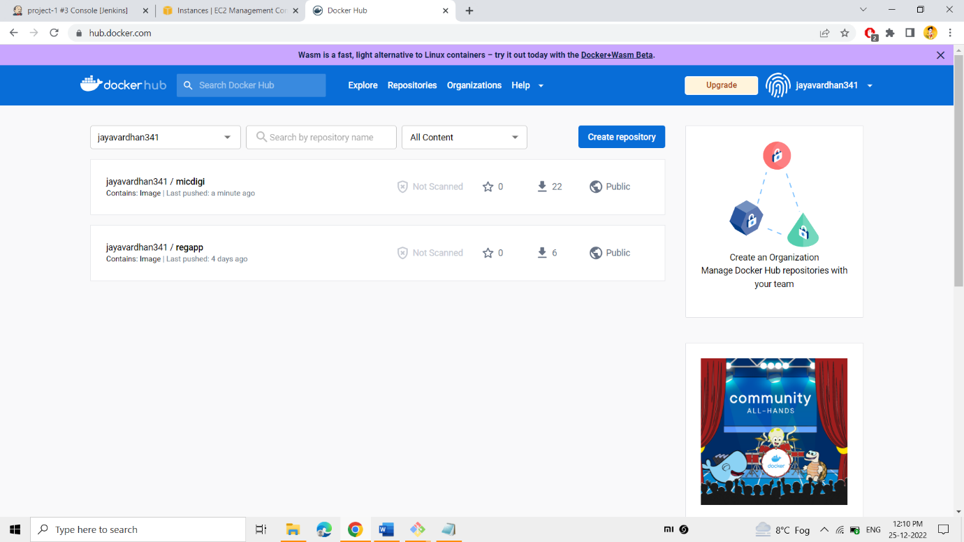

**Finally, the image has been pushed into the docker hub.**

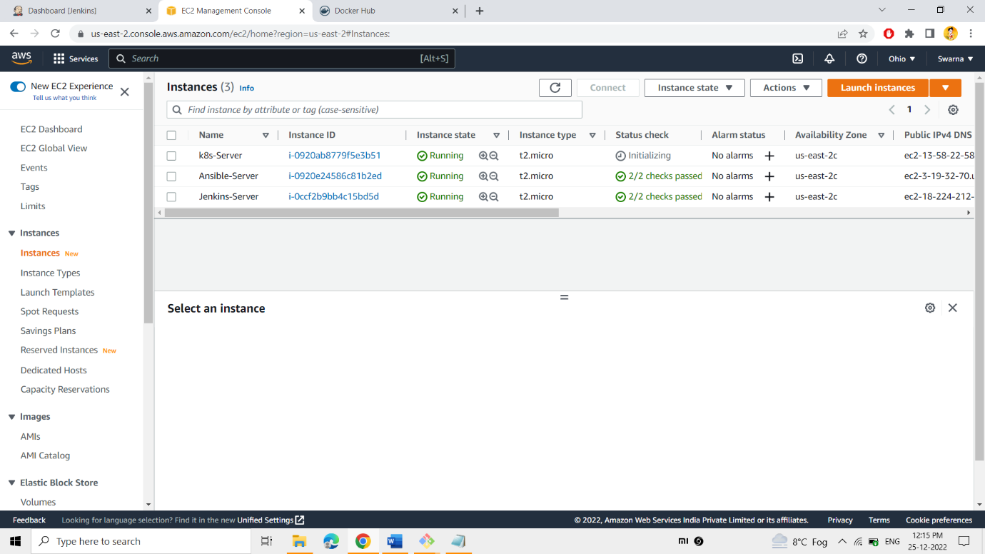

In the same way, launch the instance and name it as the K8’s server.

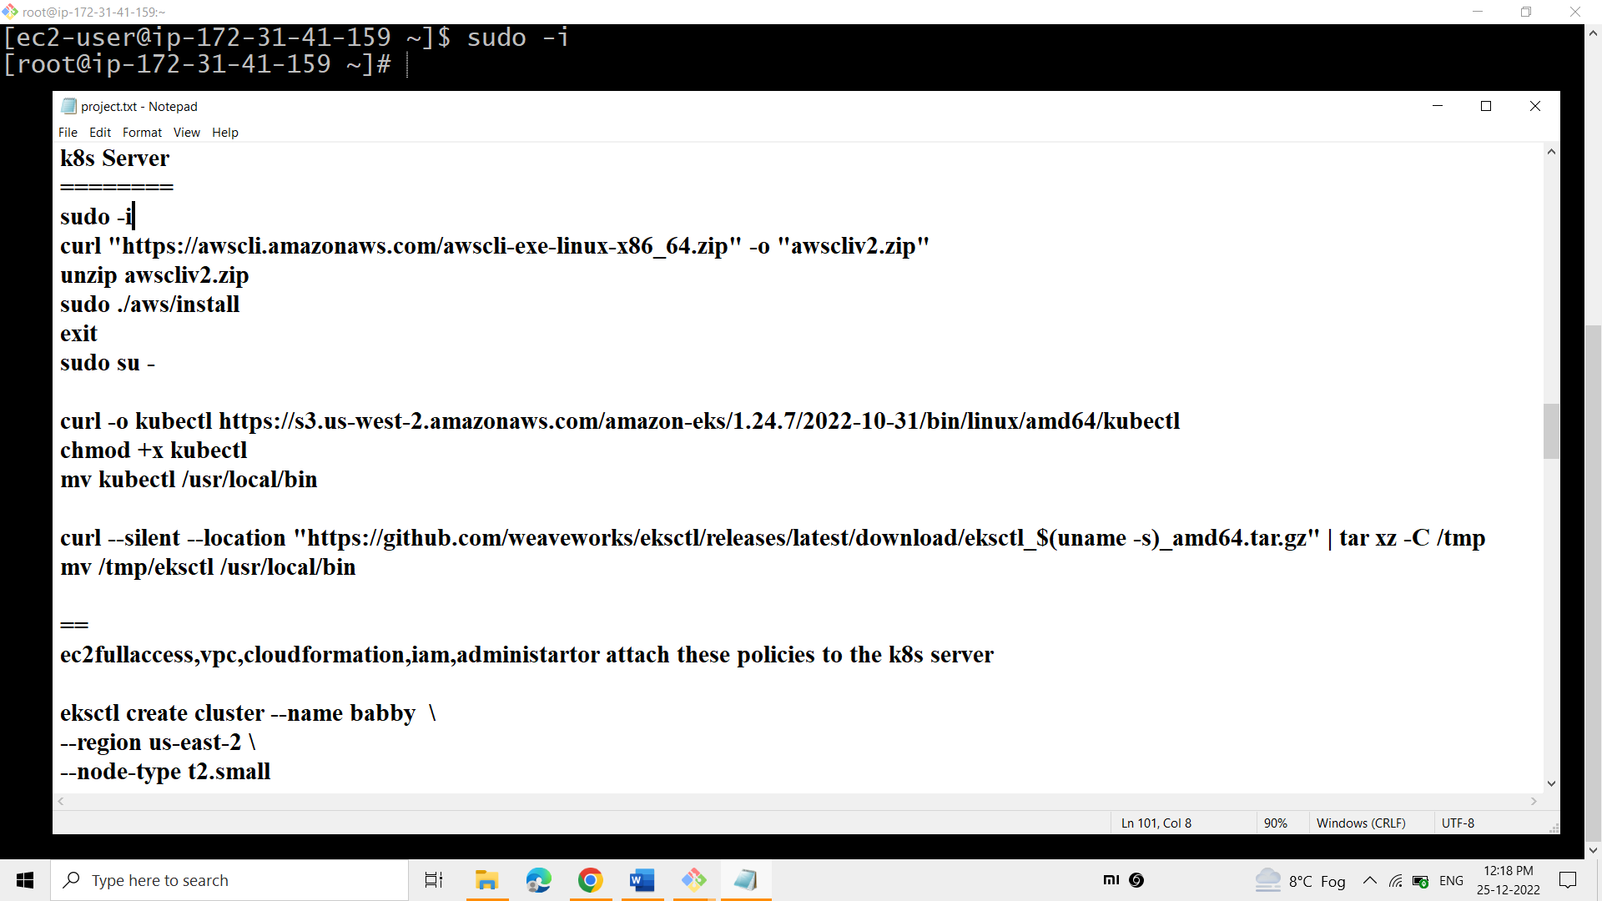

Now, in this instance need to install the Kubernetes. To install Kubernetes –

* Update the cli version with 2.9.9
* Install the Kubectl with the version of 1.24.7
* Install the Eksctl with 0.123.0

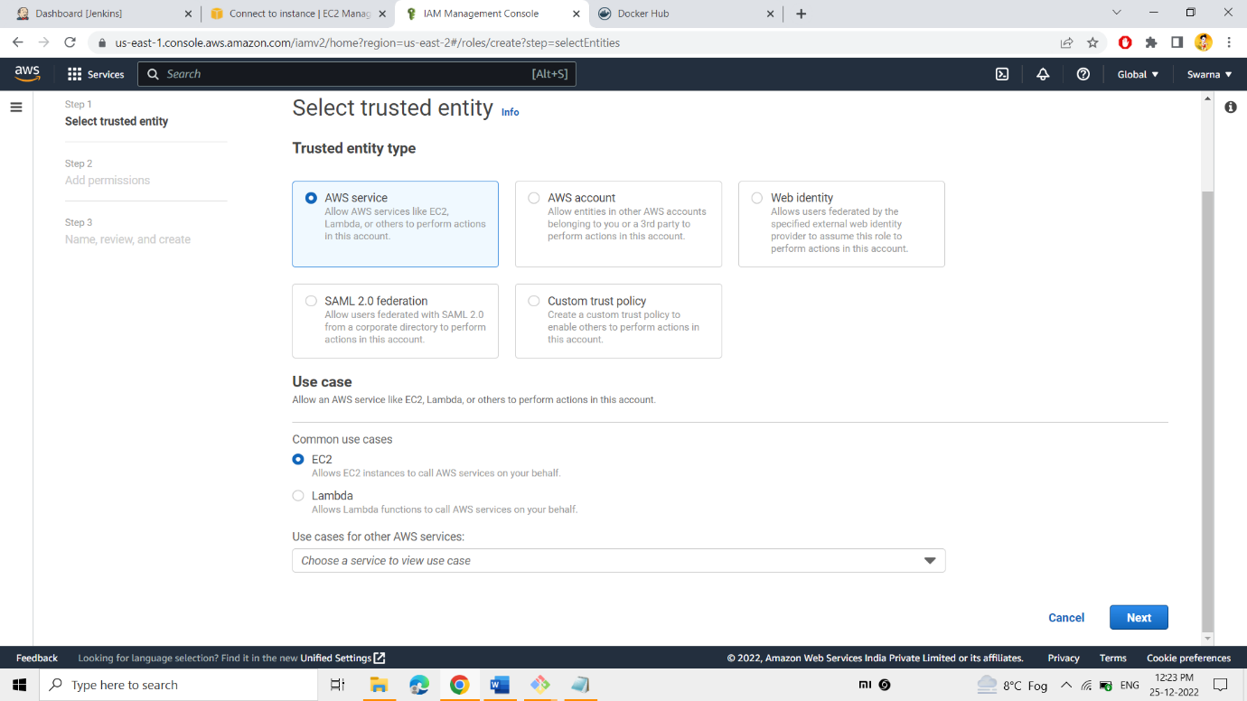

To attach certain policies to the k8’s server, select AWS service & EC2.

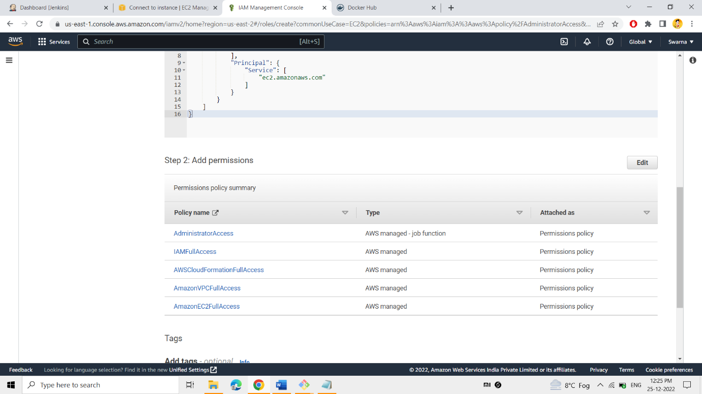

These are the 5 policies need to be attached to the k8’s server.

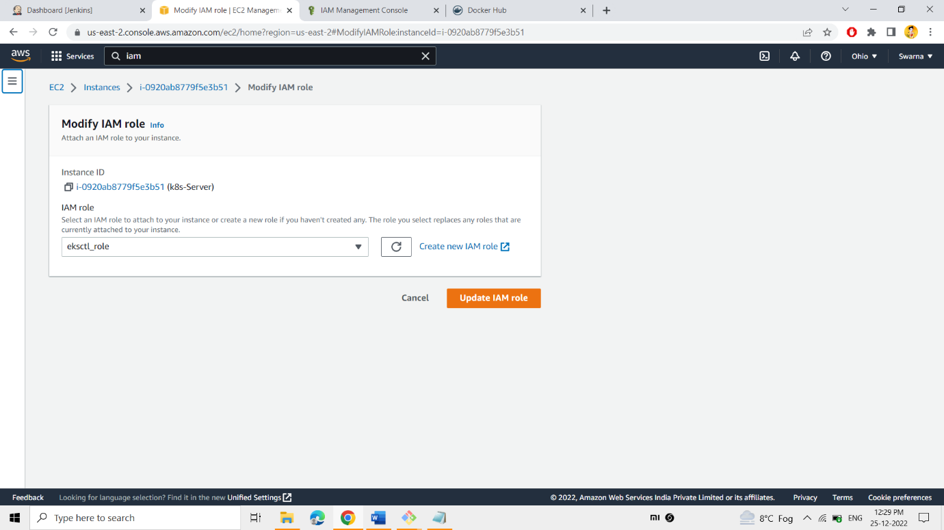

Finally, the eksctl_role has been attached to the k8’s server through the following path (Action=>security=>modify IAM role).

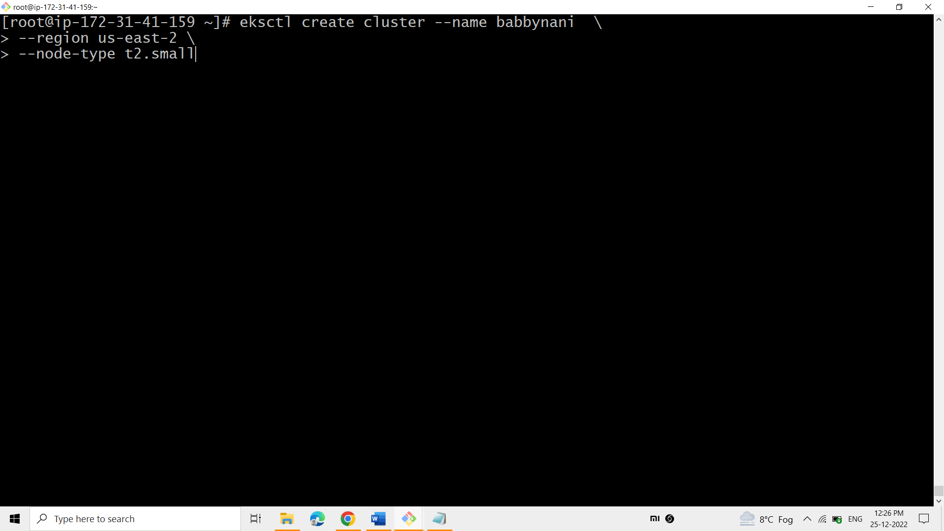

K8’s cluster has been created with the name babbynani at the region us-east-2(by seeing the instance availability zone at the ec2 dashboard).

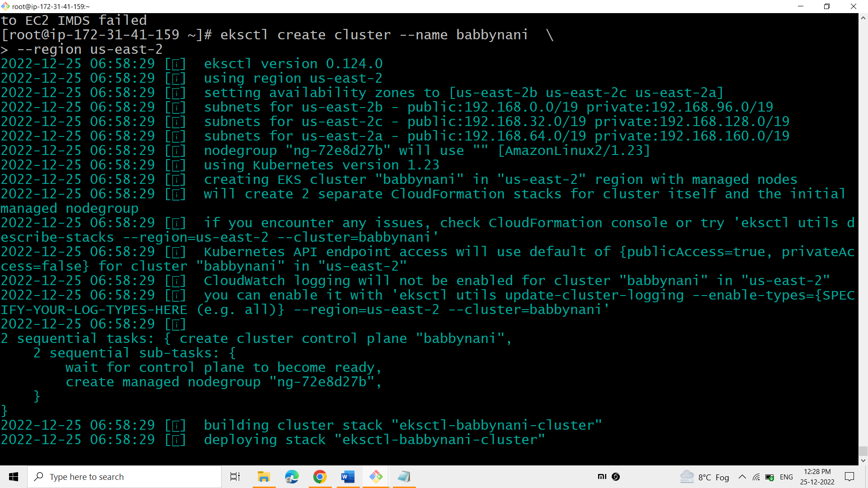

K8’s takes around 20 min to create the k8’s cluster. While creating the cluster k8’s uses CloudFormation, EC2 service to create the cluster

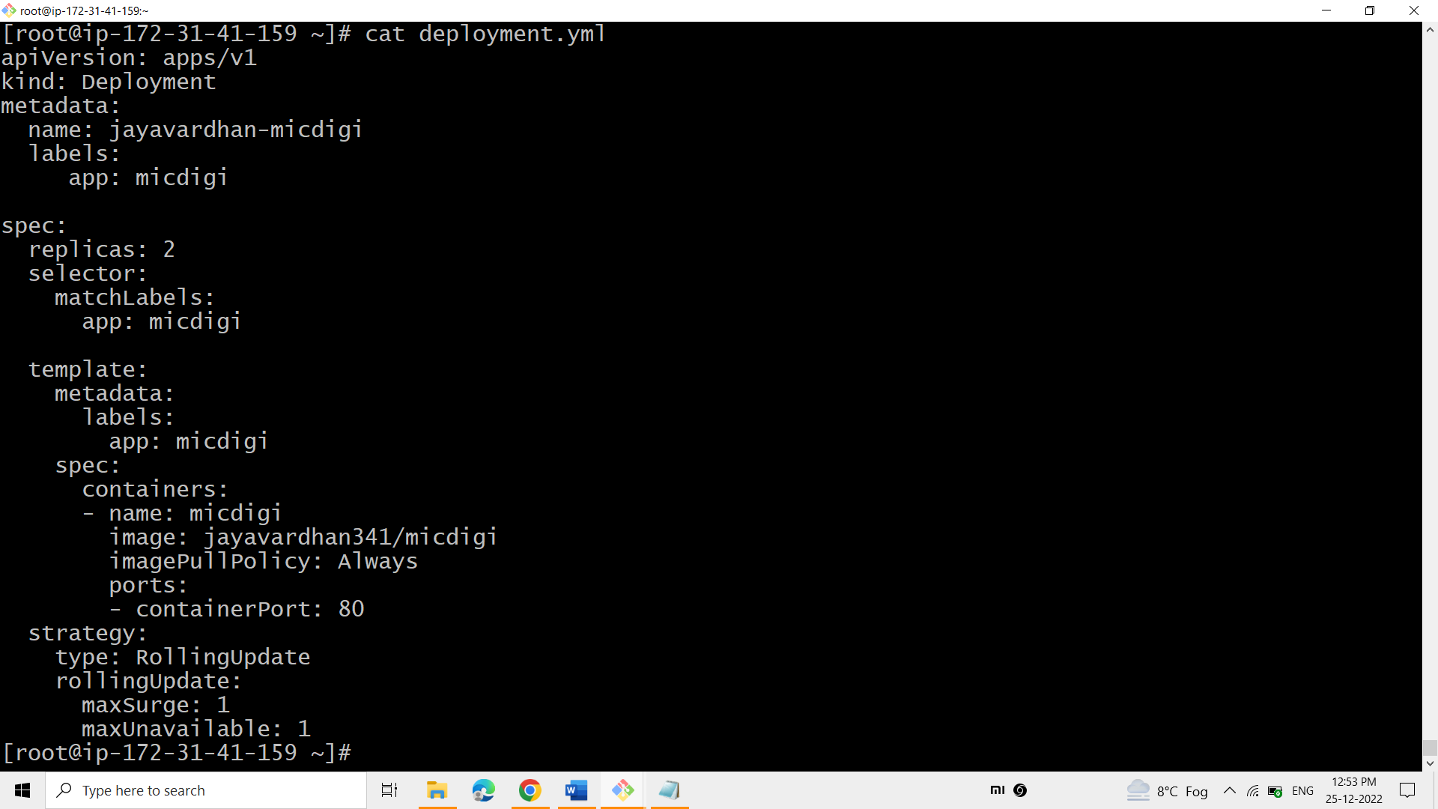

If you want to deploy your website on the internet using k8s, you need 2 files. They are: -

1. Deployment file
2. 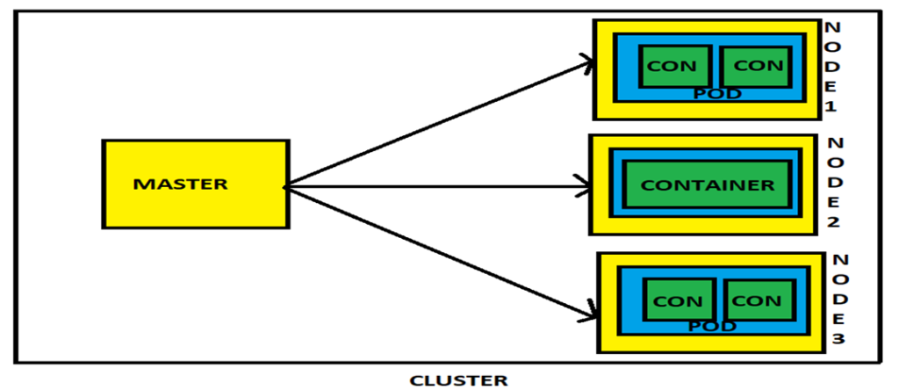Service file

Node(Yellow) = server

Pod(Blue) = template

container(green) = container

Metadata tells us the details of deployment (i.e., name of the deployment and label of the deployment).

Specs tell us the specifications of the deployment like replica tell us how many replica set we need.

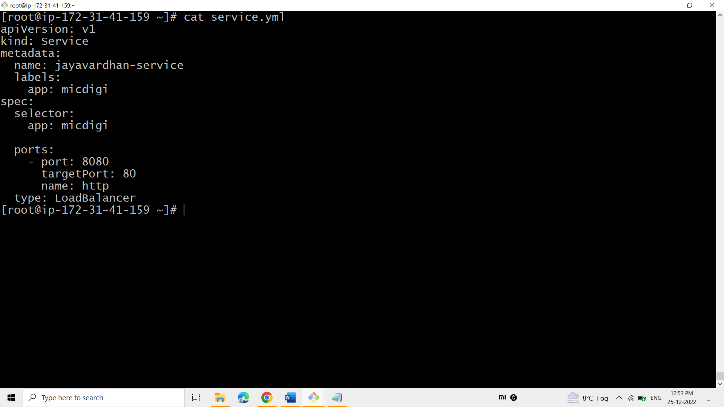

**Metadata tells us the details of service(i.e name of the service[file] and label of the service).**

**Target port is a port which run internally on defined port (8080).**

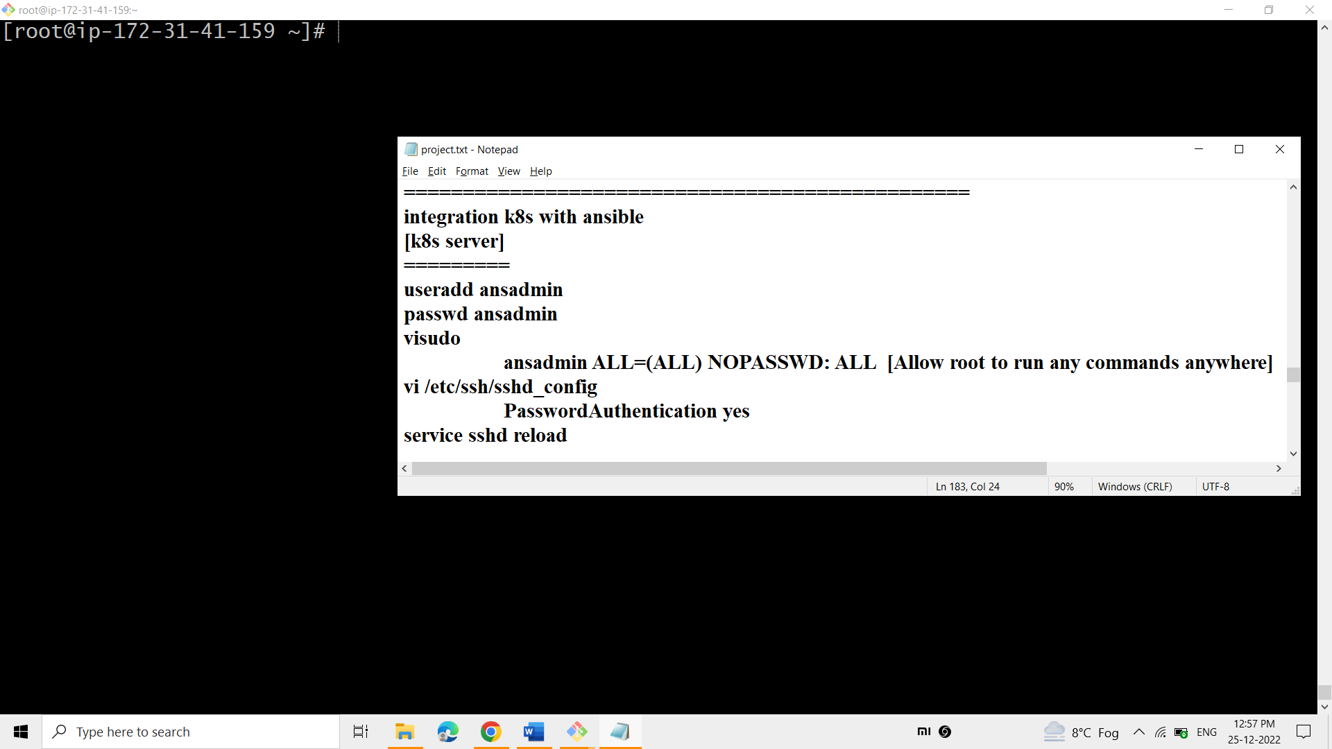

**To integrate the k8’s-server with the ansible-server easily-**

* **Add the same user in the k8’s server.**
* **Do the necessary changes in the visudo and sshd_config.**

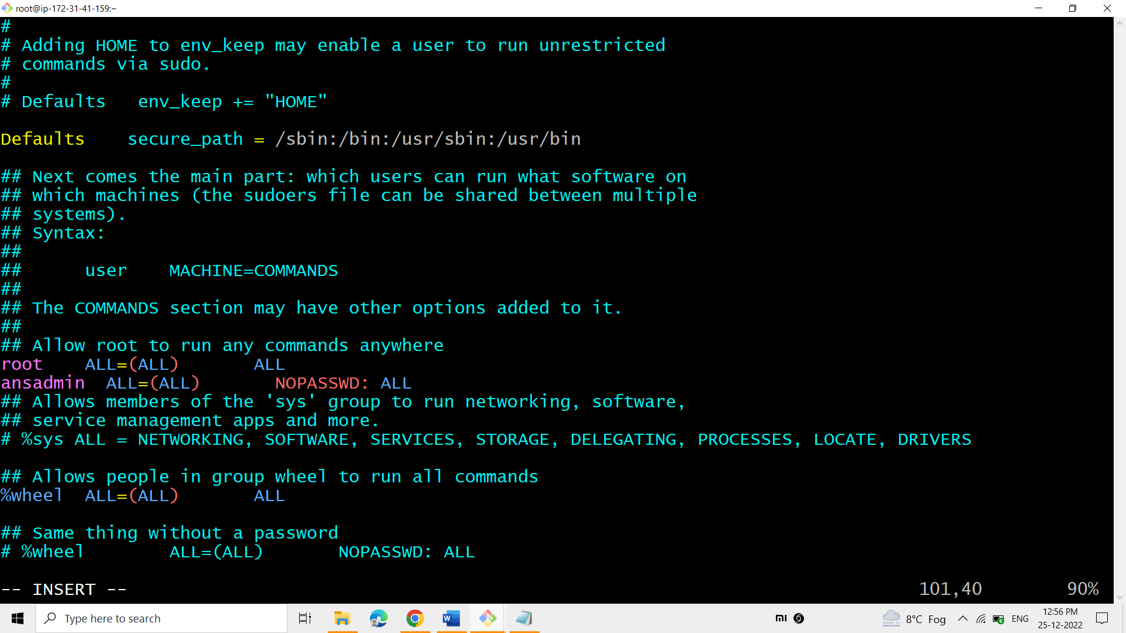

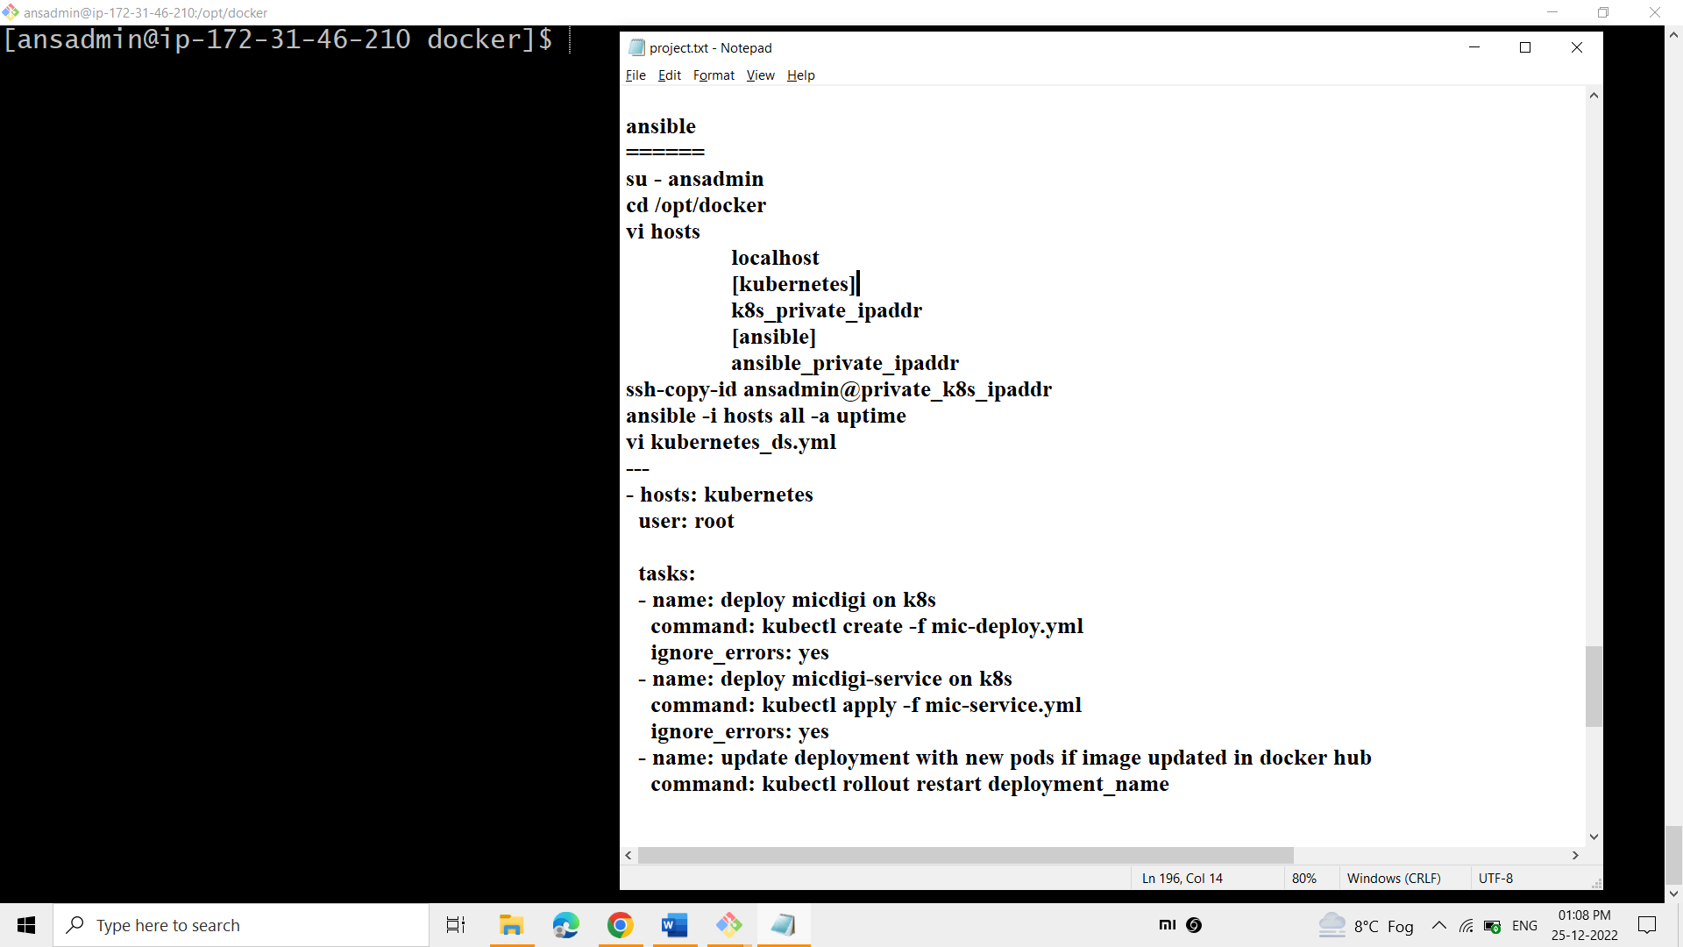

**To connect the ansible-server with the k8’s server, follow the above steps such as**

* + **Write the k8’s group and its ip address. Write the the ansible group and its ip address.**
  + **Copy the ssh of ansadmin of ansible-server to the k8’s server.**

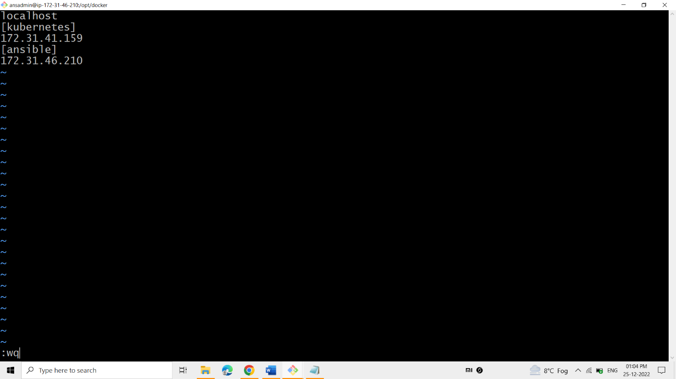

**Write the k8’s group and its ip address. Write the the ansible group and its ip address.**

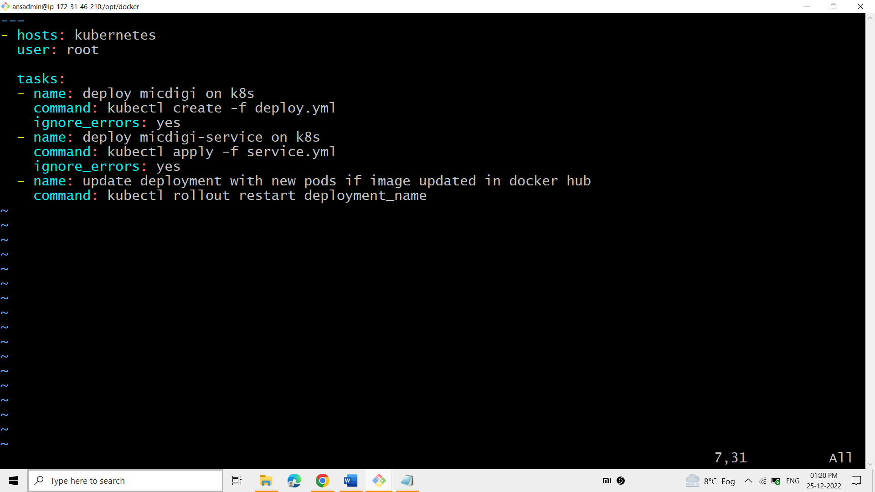

**This playbook Kubernetes_ds.yml helps in running the deploy.yml and service.yml files.**

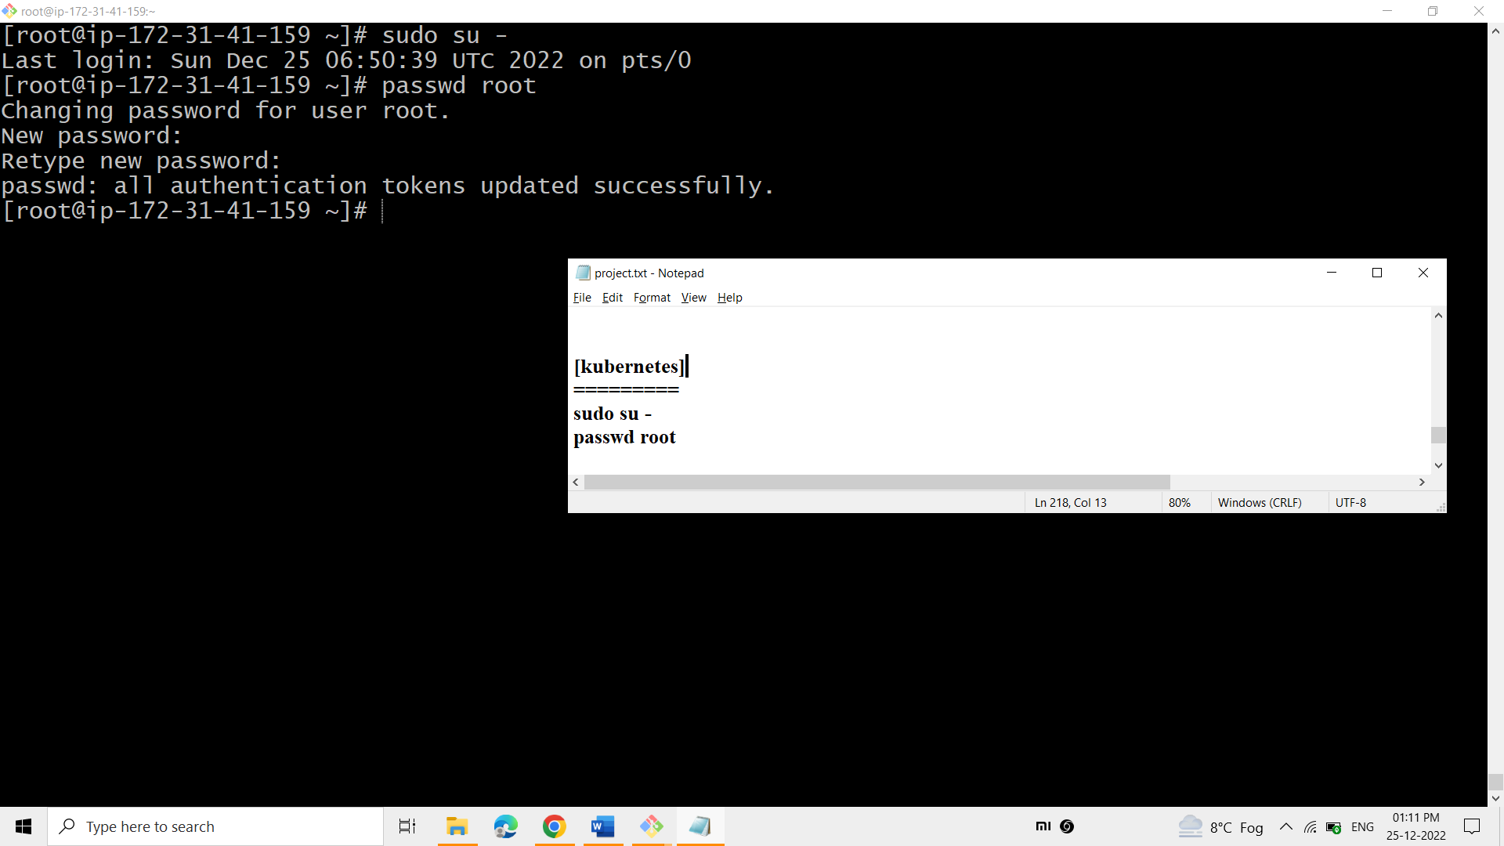**Get to know the password of the root of k8’s server.**

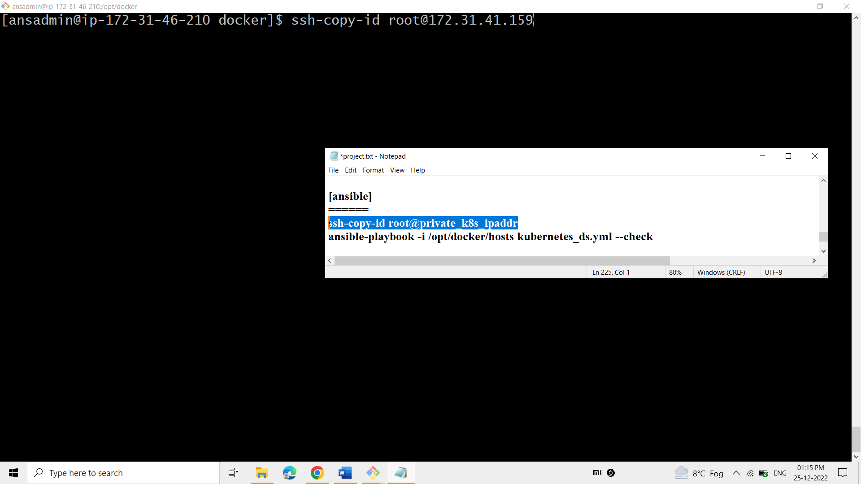

**Copy the ssh id of root of the ansible-server to the k8’s server.**

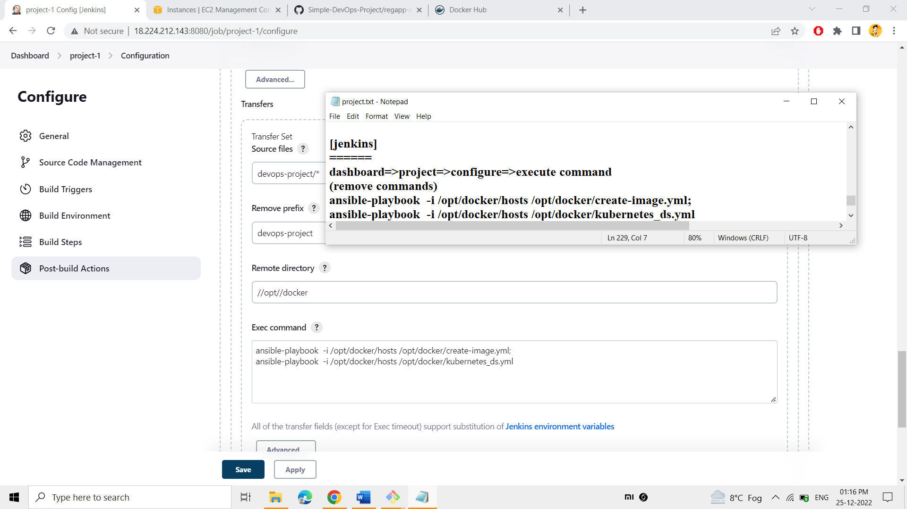

**In the field of “Exec command” give the command of running the Kubernetes_ds.yml playbook along with the create-image.yml.**

**Such that both the commands would run when automated.**

**1)Helps in creating the docker image and pushing into the docker hub.**

**2)Helps in running the deploy & service files such that pods, port, containers other stuff of k8’s would be created.**

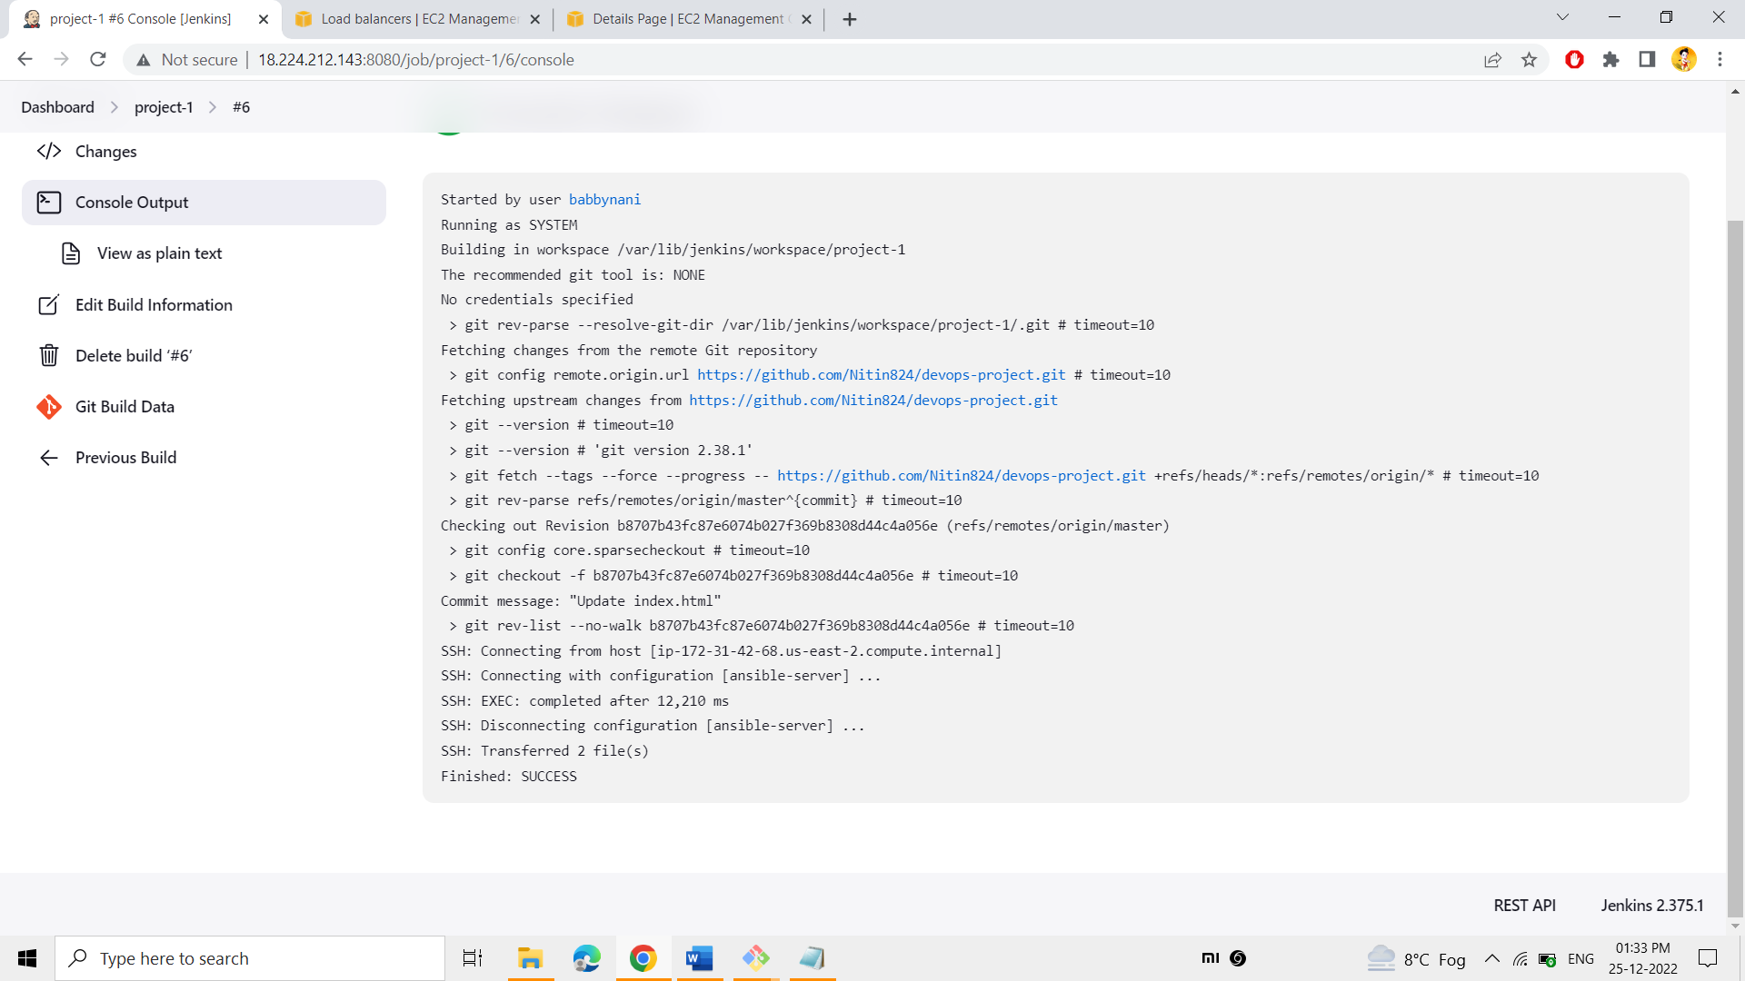

**The build was successful. So, the application, which was present in the pods of the k8’s cluster, runs successfully**

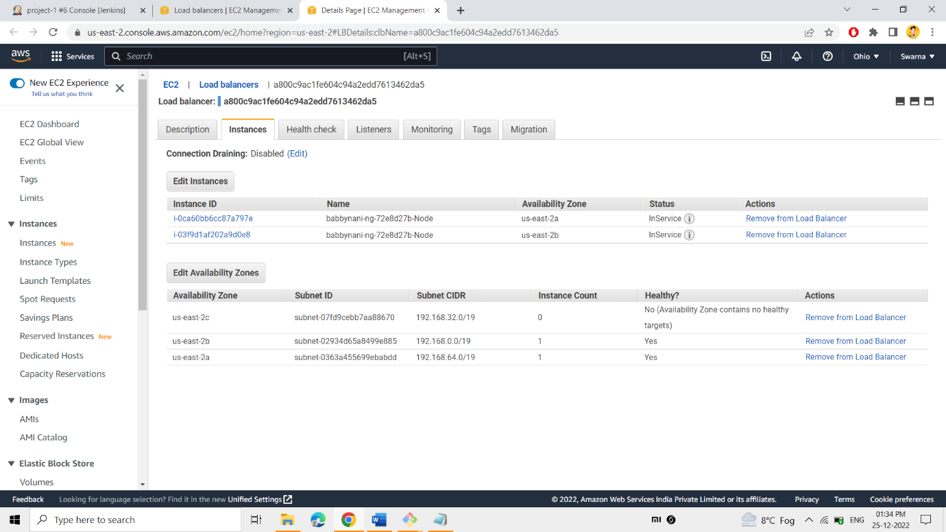

**Check the load balancer dashboard, the load balancer would run automatically, which was created by k8’s .**

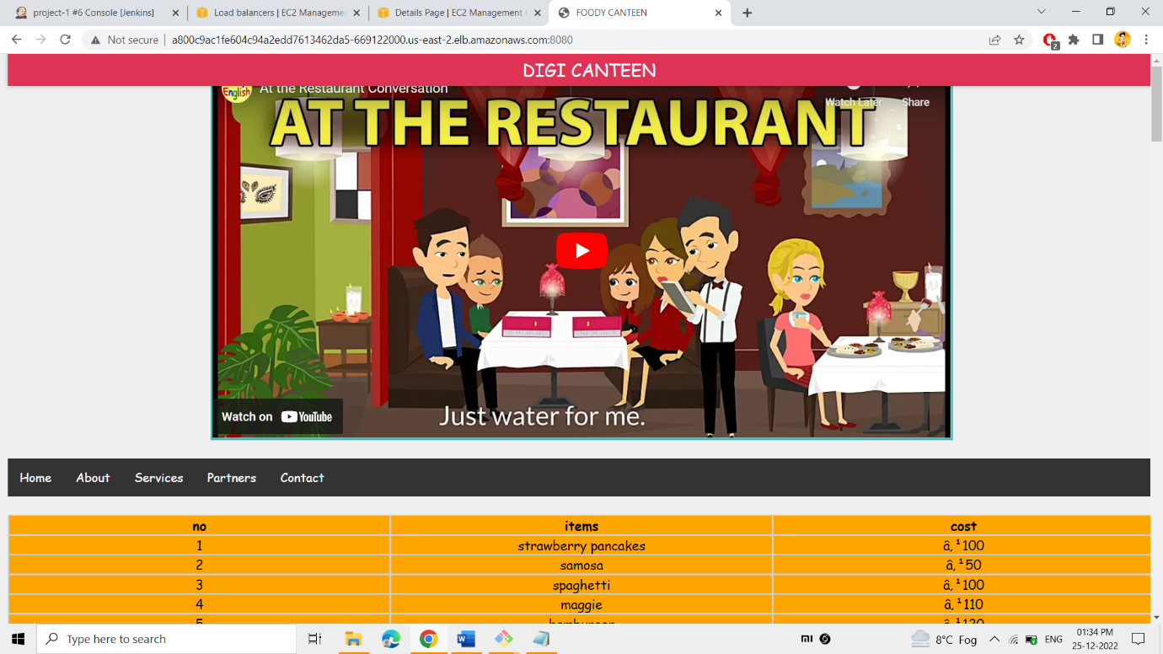

**Paste the url of the load balancer with the port which specified in service file of k8s.**

**Finally, you can be able to view the website. which was passed in the deployment file as the image in the cluster.**

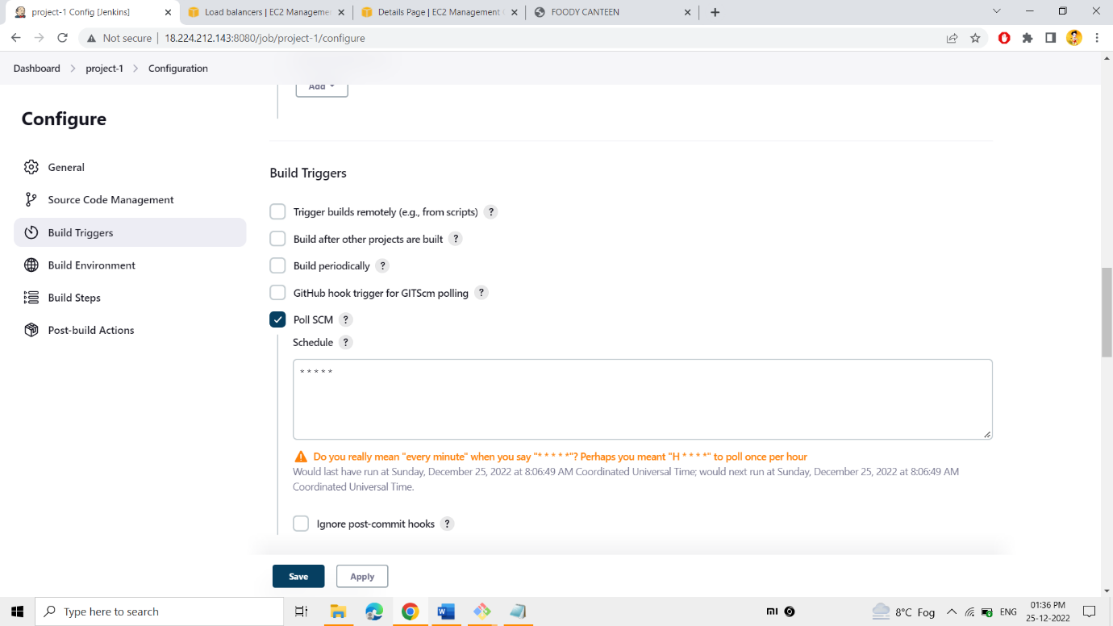

The “Poll SCM” option is used to check the GitHub for any updation of the project in every minute.

The pattern used to check the GitHub for every minute is *****.

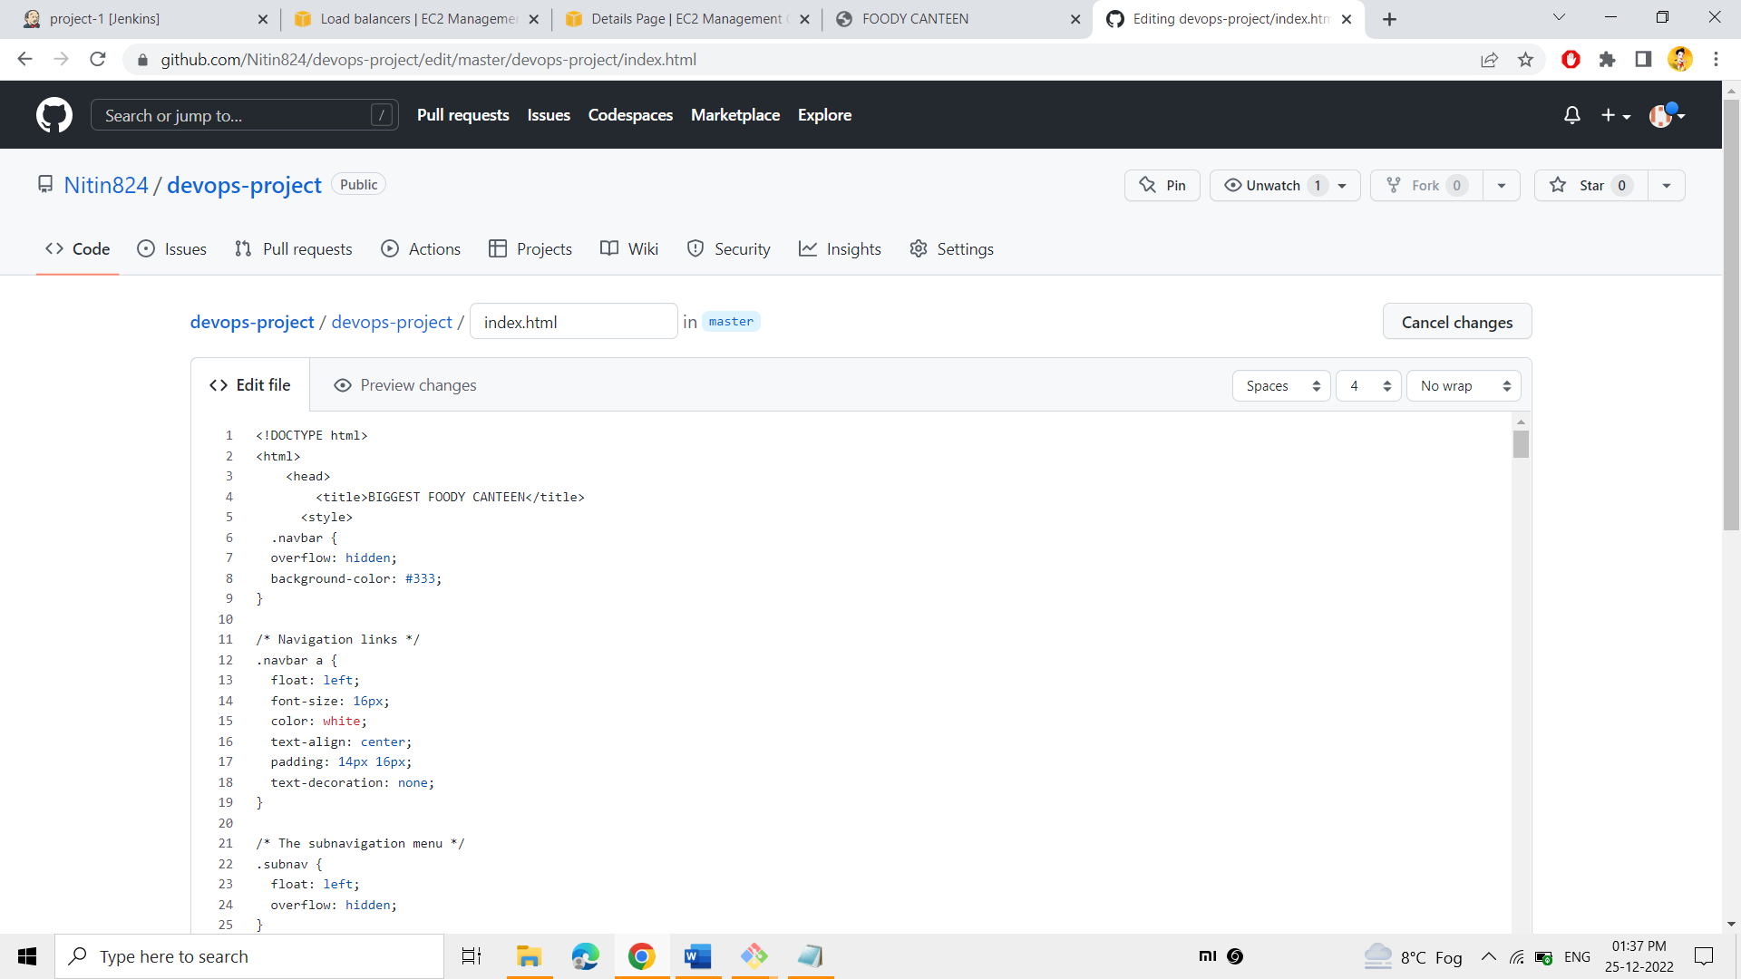

Here at the title tag “biggest foody canteen” has been updated in the GitHub

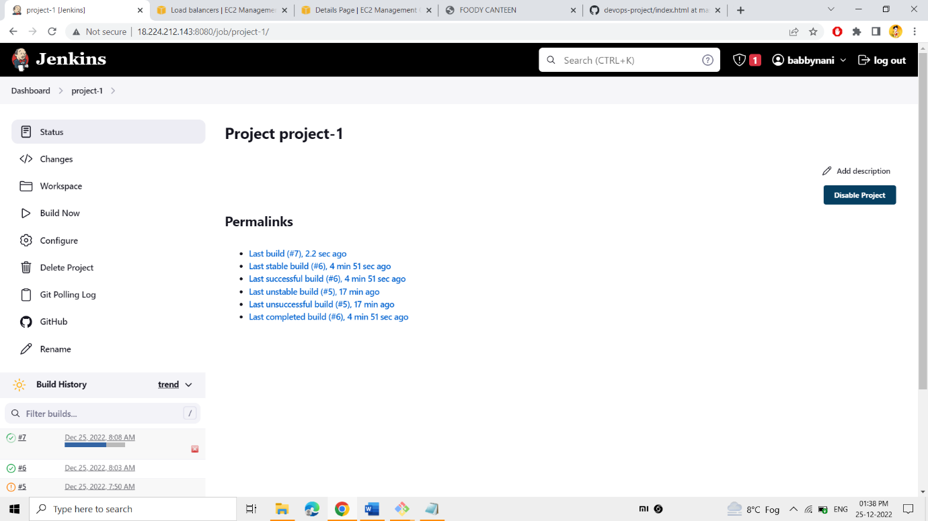

**As you can see, the project-1 Automatically builds itself when the changes have taken place.**

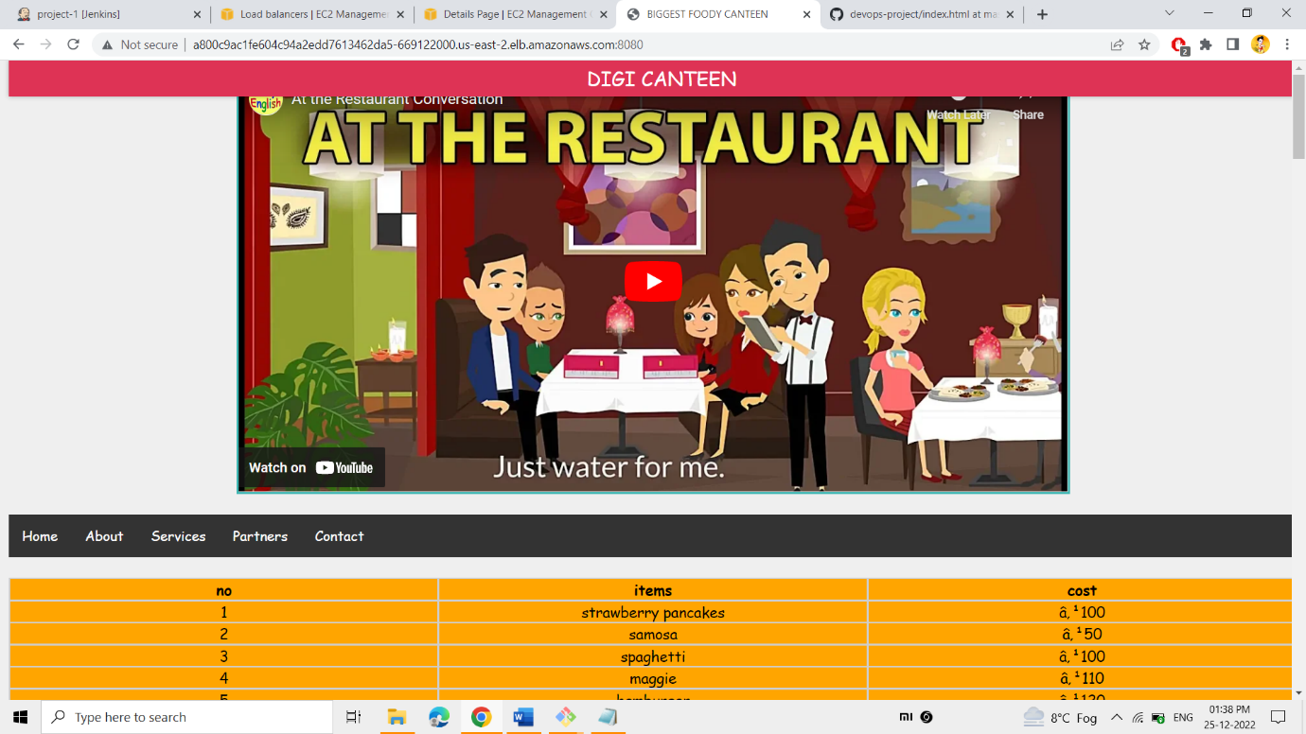

**Refresh the given link, finally you can be able to see the changes, which you have made.**

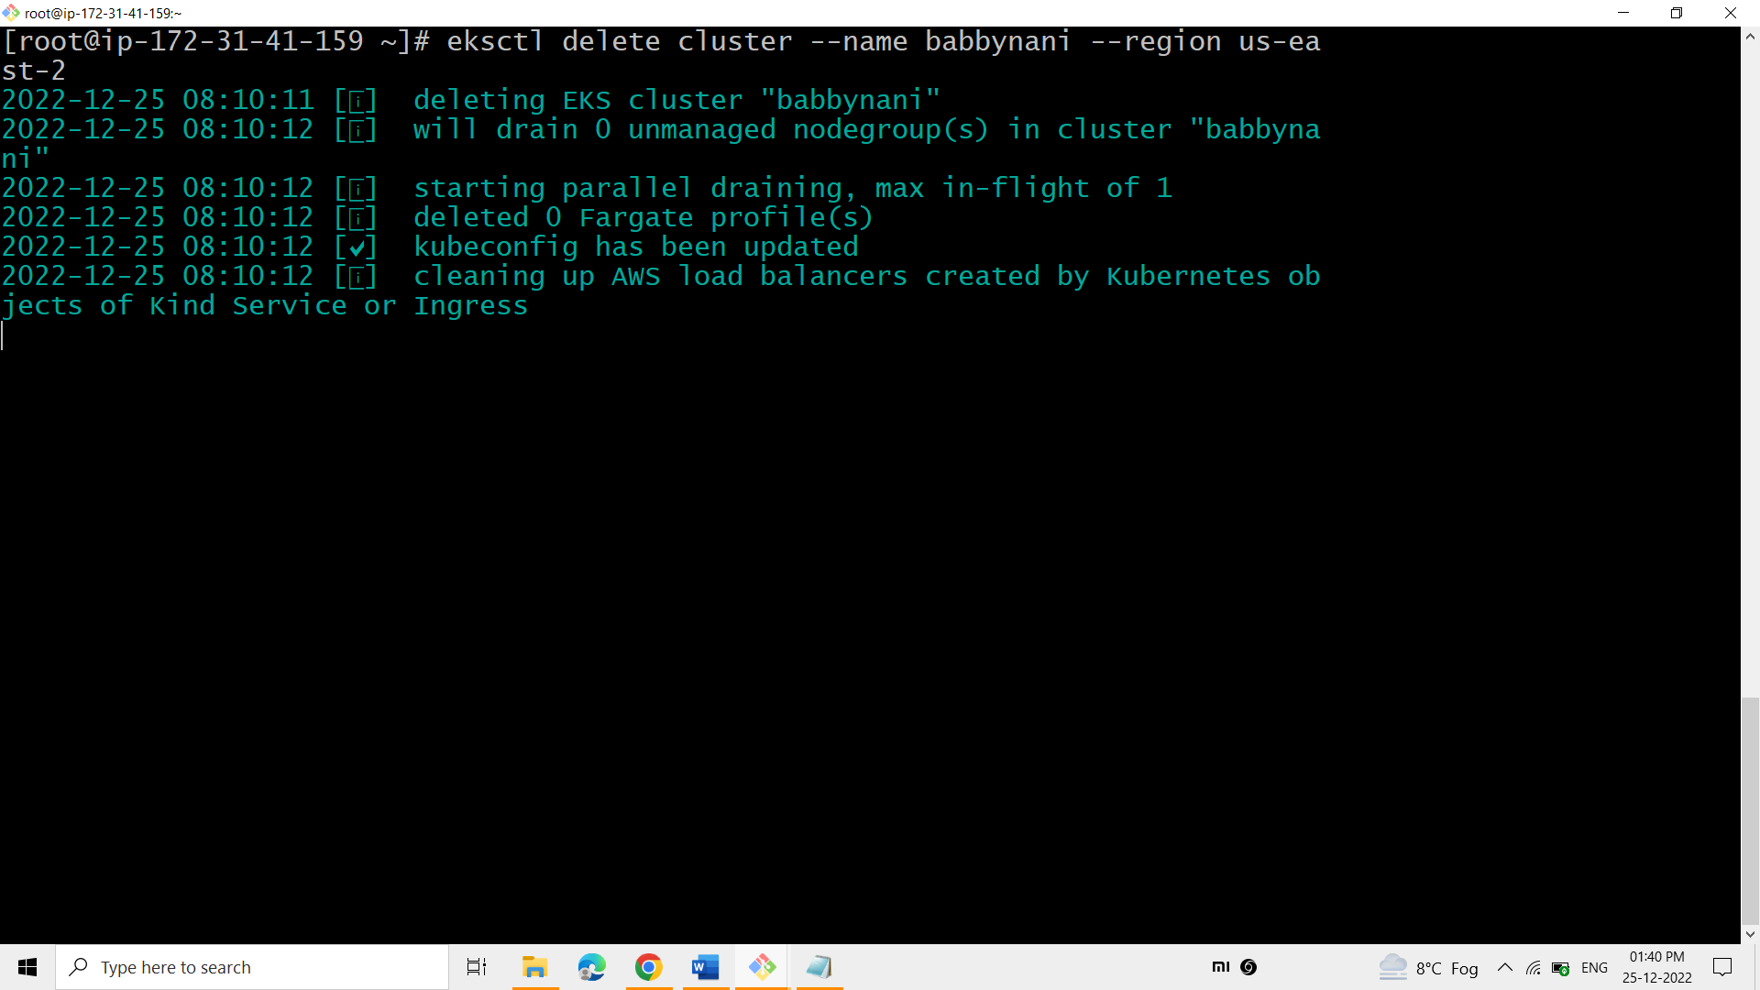

The above command is used to delete the k8’s cluster

CONCLUSION:

 I have created a complete CI/CD pipeline to run a web application. In this project, I have worked with tools like GitHub, Jenkins, docker, ansible, and Kubernetes and integrated these tools to run a project in the real world.

First & foremost, I pushed my artifacts onto the GitHub repo using Git.

Secondly, Jenkins job had been created to pull the artifacts from GitHub to the Jenkins workspace.

Established the connection between Jenkins and ansible-server to push the artifacts from Jenkins to the ansible.

To create Docker image for my web application and to Push the image into the Docker hub, an ansible-Playbook was written in ansible-server.

Next, k8’s cluster had been created and integrated my docker hub image with the k8’s cluster.

An ansible playbook had been written to run the deployment and service files of k8’sand it is incorporated in Jenkins

Finally, POLL SCM was activated such that, whenever the changes has been made in the artifacts of Git hub, the changes would be reflected into my web application time-to-time.